Research Proposal: Deciphering the Philippines’ Volume of Net Sales Index (VoNSI) in Manufacturing:

Dynamics, Challenges, and Areas for Development

Jomari Manto   
*College of Computer Studies & Engineering*  
*Jose Rizal University*Mandaluyong City, Philippines  
[jomari.manto@my.jru.edu](mailto:jomari.manto@my.jru.edu)

Blanzy Gwyneth Faith N. Cinco  
*College of Computer Studies & Engineering*  
*Jose Rizal University*Mandaluyong City  
[blanzygwynnethfaith.cinco@my.jru.edu](mailto:blanzygwynnethfaith.cinco@my.jru.edu)

August Brillo  
*AUGUST, The Pomeranian*  
Kai Gardens ResidencesMandaluyong City, Philippines  
<https://www.instagram.com/august_thepomeranian/>

***Abstract*—This research proposal examines the dynamics of the Philippines' manufacturing sector, a key driver of the country's macroeconomic performance. By analyzing historical Volume of Net Sales Index (VoNSI) data at the national level, the study explores the sector’s trends, challenges, and areas for development. Utilizing both prescriptive and predictive analytics, it aims to identify weak points in the sector, provide data-driven recommendations for improvement, and ensure that well-performing industries maintain their momentum.(***Abstract***)**

***Keywords—Philippine manufacturing sector, Volume of Net Sales Index (VoNSI), Philippine economy, economic development, macroeconomic performance, trade and industry, economic indicators, trade liberalization (****keywords****)***

# Introduction

The manufacturing sector is a key driver of economic performance in developing countries, significantly contributing to Gross Domestic Product (GDP). However, global dynamics have influenced this industry, leading some researchers and academics to argue that manufacturing has lost its role as a primary engine of economic growth. Contrary to this claim, Szirmai and Verspagen [1] conducted an extensive analysis covering the period 1950–2005, which reinforces the sector’s continued importance. Their research confirms that manufacturing remains a crucial factor in economic performance, particularly in developing countries like the Philippines.

In the context of the Philippines, numerous studies have identified persistent challenges in the manufacturing sector, including structural inefficiencies, supply chain vulnerabilities, and fluctuating market demand. As a developing country, the Philippines must pay greater attention to this industry to unlock its full potential and drive sustainable economic growth. Strengthening the manufacturing sector is essential not only for enhancing productivity and competitiveness but also for ensuring long-term economic resilience in an increasingly volatile global market.

# Problem Statement

Although the manufacturing sector plays a vital role in the Philippine economy, its growth and competitiveness continue to face significant challenges. In 2023, it contributed ₱3.78 trillion, equivalent to 17.6% to the country's Gross Domestic Product (GDP) [2]. Despite its substantial contribution and strong performance in recent years, the manufacturing sector has yet to reach its full potential. Persistent challenges continue to hinder its growth, limiting its ability to drive broader economic expansion.

A 2024 report highlights that the Philippines struggles to become a manufacturing powerhouse due to various challenges [3] such as:

1. Shrinking Economic Share – Since the 1980s, the manufacturing sector's share of GDP has declined, while services have taken a larger role.
2. Low Foreign Investments – In 2022, the Philippines attracted only $9.2 billion in Foreign Direct Investment (FDI), lagging behind Vietnam ($17.9B), Indonesia ($21.7B), and Singapore ($140.8B).
3. Skilled Labor Shortage – A lack of highly trained workers limits productivity and slows industry growth.
4. Weak Governance – Corruption and bureaucratic inefficiencies continue to discourage investors and stall development.
5. Energy Crisis Risk – Rising electricity costs and supply concerns threaten manufacturing operations and future expansion.

Deluna’s [4] research also identified the following challenges in the Philippine manufacturing sector:

1. Ineffective Trade Agreements – ASEAN and WTO memberships have had little impact on improving the country’s trade efficiency, limiting export growth.
2. High Trade Costs – Long shipping distances and logistical inefficiencies increase costs, making Philippine exports less competitive.
3. Underutilized Export Potential – The county underperforms in trade with key partners like Vietnam, Indonesia, and Thailand, missing growth opportunities.
4. Regulatory and Customs Delays – Slow and complex trade facilitation processes increase transaction costs, reducing efficiency.
5. Export Market Imbalance – Philippine imports outweigh exports, leading to a persistent trade deficit and dependence on foreign goods.

Moreover, Tecson [5], in his research, identified the following challenges:

1. Outdated Technology – Many manufacturing firms still use old machinery, making them less productive and globally uncompetitive.
2. Weak R&D Investment – Local firms spend little on innovation, limiting their ability to improve products and production efficiency.
3. Market Barriers – Large firms dominate certain industries, making it harder for small and medium enterprises (SMEs) to compete.
4. Failed Protection Policies – Past government support for industries like textiles and paper did not lead to competitiveness, resulting in inefficiencies.
5. Misaligned Industrial Policies – Government programs fail to address real industry needs, leading to inconsistent support and poor long-term planning.

Addressing these challenges requires more than just the findings of this study. Therefore, this research aims to provide insights that can serve as a foundation for further exploration by answering key research questions.

# Research Questions

To further examine the challenges facing the Philippine manufacturing sector, this study aims to explore key research questions using relevant data as indicators of industry performance. The proposed research seeks to answer the following questions:

1. Key Performance Indicators – Which statistical measures (e.g., growth rates, industry comparisons, historical trends) best reflect the performance of the Philippine manufacturing sector, and why are they significant?
2. Historical Trends – How has the Philippine manufacturing sector performed over time? Has it shown sustained growth, decline, or cyclical fluctuations?
3. Sectoral Comparison – Which manufacturing industries have exhibited the highest and lowest growth rates, and what factors contribute to their varying performance?
4. Economic & External Influences – What major economic events (e.g., recessions, policy shifts, global disruptions) have impacted the performance of the manufacturing sector?
5. Forecasting Potential – Can historical data trends be used to predict future performance in the manufacturing sector? What statistical techniques can provide reliable insights?

By answering these questions, this study aims to generate insights that lay the foundation for understanding and addressing challenges in the Philippine manufacturing sector.

# Research Objectives & Performance Indicators

The primary objective of the proposed research are as follows:

1. Understand long-term trends – Examine how the Philippine manufacturing sector has performed over the years based on historical data.
2. Identify top and low-performing industries – Determine which manufacturing sectors are growing the fastest and which ones are struggling.
3. Compare industry growth patterns – Find out which industries contribute the most to the sector’s overall growth.
4. Explore future trends – Use past data to see if patterns can help predict future sales performance in manufacturing.

In addition, the proposed research will use the following quantifiable variables as performance indicators:

1. Yearly Growth Rates – To see if the sector is improving or declining.
2. Industry Rankings – To determine the best and worst-performing manufacturing sectors.
3. Stability of Growth – To check if the industry is steadily growing or experiencing ups and downs.
4. Predictive Accuracy – If forecasting is applied, how well past data can predict future trends.

# Literature Review

Manufacturing is a key driver of economic growth, yet studies show that the Philippine manufacturing sector faces persistent challenges. This section reviews previous research to highlight key issues and existing business analytics approaches used to study similar problems.

## *Manufacturing and Economic Growth*

Szirmai and Verspagen (2018) found that manufacturing boosts productivity, job creation, and economic growth, especially in developing countries. While their study does not focus specifically on the Philippines, their findings highlight the importance of analyzing trends in the country’s manufacturing sector.

*B. Challenges in the Philippines*

Deluna (2013) found that high trade costs, inefficient logistics, and complex regulations make Philippine exports less competitive. His study used a Stochastic Frontier Gravity Model to measure how well the country utilizes its trade potential, highlighting the need for policy improvements in trade efficiency. While his research focused on overall trade performance, these factors also impact the manufacturing sector, which relies heavily on exports and international market access.

Tecson (1992) identified low productivity, outdated technology, and weak industrial policies as major obstacles to manufacturing growth. The study compared the Philippines to its ASEAN neighbors and found that a lack of technological investment and slow policy reforms have contributed to its declining competitiveness.

Biemudo et al. (2022) further revealed that poor infrastructure, weak local supply chains, and low foreign investment limit the country’s ability to expand its industrial capacity. Although their study focuses on broader economic conditions, these issues directly affect manufacturing businesses, which depend on efficient supply chains and infrastructure for growth. Despite trade liberalization efforts, the Philippines has struggled to attract investors due to uncertain economic policies and underdeveloped industrial zones, which hinder long-term industrial expansion [6].

*C. Business Analytics Approaches*

Several business analytics methods have been used to examine economic and industrial performance, but each has limitations when applied to the Philippine manufacturing sector:

Trade Efficiency Models (Deluna, 2013) – Evaluate how efficiently the Philippines engages in global trade, but they do not provide real-time insights into market conditions or industry fluctuations.

Sectoral Performance Analysis (Tecson, 1992) – Offers historical data on manufacturing competitiveness, yet may not accurately reflect current industry trends due to evolving market conditions.

Policy Impact Studies (Biemudo et al., 2022) – Identify structural weaknesses and economic barriers affecting manufacturing, but do not incorporate predictive analytics to forecast future industry performance.

These studies emphasize the need for a data-driven approach to analyzing Philippine manufacturing. Modern techniques like time-series forecasting and statistical modeling can provide more accurate, forward-looking insights, supplementing existing research.

# Data Sourcing and Processing

1. *Volume of Net Sales Index (VoNSI)*

To conduct this research, the study will utilize national data on the Volume of Net Sales Index (VoNSI), which measures changes in the net sales output of the manufacturing sector relative to a reference period and base year [7].

The Volume of Net Sales Index (VoNSI) tracks changes in the number of products sold by the manufacturing sector over time, regardless of price changes. It helps measure whether businesses are selling more or fewer goods compared to previous years and serves as a key industry indicator.

As a measure of industry performance, VoNSI helps track sales volume trends and growth rates, aligning with the study’s objectives of identifying historical patterns, comparing sectoral performance, and assessing external factors affecting the manufacturing sector.

1. *Data Sources & Preprocessing*

As of writing this stage, the researchers have established the following as potential data sources:

1. Volume of Net Sales Index (VoNSI) and Year-on-Year Growth Rates for Manufacturing

Source: Philippine Statistics Authority (PSA)

Description: This dataset tracks the sales volume and growth rates of the manufacturing sector, providing insights into historical trends and sectoral performance. Link: [PSA OpenSTAT - Manufacturing Volume of Net Sales Index](https://openstat.psa.gov.ph/Metadata/2G4CMSO0)

2. Annual Survey of Philippine Business and Industry (ASPBI)

Source: Philippine Statistics Authority (PSA)

Description: The ASPBI provides detailed business statistics, including employment, compensation, revenue, and costs for the manufacturing sector. It offers a holistic view of industry performance beyond just sales. [Link: PSA - Annual Survey of Philippine Business and Industry (ASPBI)](https://psa.gov.ph/statistics/survey/business-and-industry/index)

The study will utilize R programming for data processing, visualization, and analysis.

1. *Methodologies*

The proposed research will use two key business analytics methods:

1. Descriptive Analytics – This involves Exploratory Data Analysis (EDA) and data visualization to examine historical VoNSI and Year-on-Year Growth Rates. By identifying trends, patterns, and fluctuations in the manufacturing sector, this method provides a data-driven understanding of industry performance.
2. Predictive Analytics – This applies statistical modeling and time-series forecasting to estimate future sales volume trends. Visualization techniques will also be used to present forecasted trends and potential industry shifts, helping anticipate economic influences and external disruptions.

By combining these methods, the study will analyze past trends, visualize key insights, and predict future outcomes, offering valuable guidance for businesses, policymakers, and researchers.

*D. Potential Ethical Issues*

This proposed research will use publicly available data from the Philippine Statistics Authority (PSA), minimizing privacy concerns. However, the research will ensure:

1. Data Integrity – Official sources will be used, and preprocessing steps will be documented for transparency.
2. Proper Attribution – All datasets and references will be cited following IEEE standards to avoid plagiarism.
3. Accurate Representation – Findings will be presented objectively to prevent bias or misinterpretation.
4. Responsible Forecasting – Predictive models will include limitations to avoid misleading conclusions.

By following these ethical guidelines, the study ensures credibility, transparency, and responsible data analysis.

# Project Timeline

This proposed research will follow a structured three-week timeline to ensure the efficient completion of research tasks.

The schedule outlines key activities, including literature review, data collection, preprocessing, exploratory analysis, predictive modeling, and final documentation. Each phase builds on the previous one, allowing for a systematic approach to analyzing manufacturing trends using VoNSI data. Please refer to the figure on the next page.

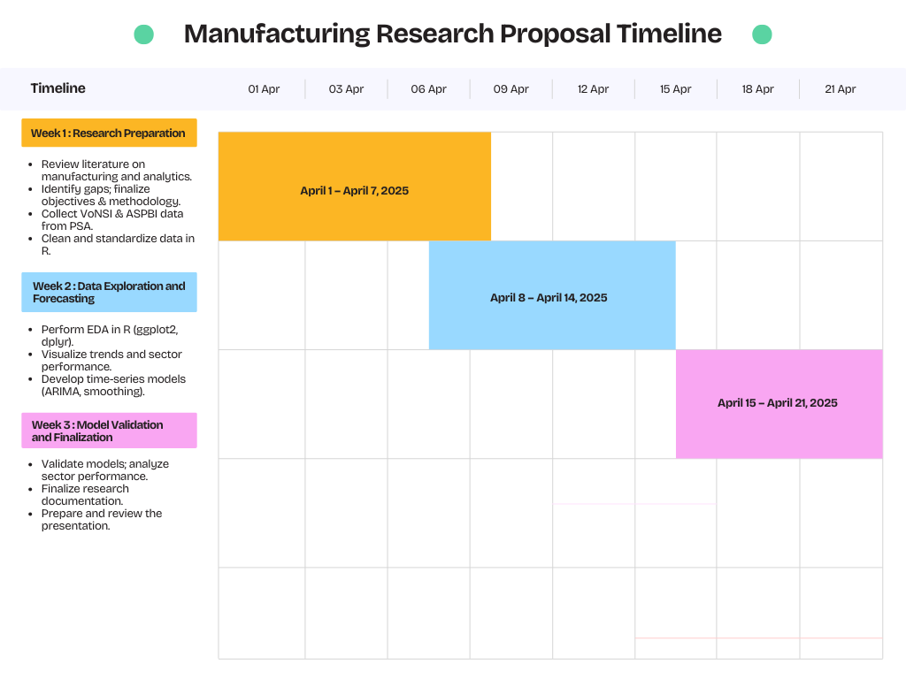

*Figure VII.1. Proposed Time Table*

# References

1. A. Szirmai and B. Verspagen, "Manufacturing and Economic Growth in Developing Countries, 1950–2005," *World Development*, vol. 109, pp. 338–350, 2018, doi: 10.1016/j.worlddev.2018.05.005.
2. Statista Research Department, "Manufacturing sector in the Philippines - statistics & facts," Statista, Jan. 2025. [Online]. Available:<https://www.statista.com/topics/11457/manufacturing-in-the-philippines/>. [Accessed: 27-Mar-2025]
3. BusinessWorld, "Becoming a manufacturing powerhouse remains a pipe dream for Philippines," *BusinessWorld Online*, Jan. 3, 2024. [Online]. Available:<https://www.bworldonline.com/top-stories/2024/01/03/566473/becoming-a-manufacturing-powerhouse-remains-a-pipe-dream-for-philippines/>. [Accessed: Mar. 27, 2025]
4. R. S. Deluna Jr., "Trade Performance and Potential of the Philippines: An Application of Stochastic Frontier Gravity Model," Munich Personal RePEc Archive, Paper No. 51677, Apr. 30, 2013. Available: https://mpra.ub.uni-muenchen.de/51677/. [Accessed: 18-Mar-2025].
5. G. R. Tecson, Performance, Competitiveness, and Structure of Philippine Manufacturing Industries: A Research Design. Makati: Philippine Institute for Development Studies, 1992
6. K. G. Biemudo, R. V. Antonio, and N. A. J. Agustin, "An Empirical Analysis on the Impact of International Trade in Philippine Economic Growth," *J. Econ. Finance Account. Stud.*, vol. 4, no. 1, pp. 607–628, 2022. [Online]. Available:<https://www.al-kindipublisher.com/index.php/jefas>. [Accessed: 18-Mar-2025].
7. Philippine Statistics Authority, "Volume of Net Sales Index (VoNSI) - Metadata," *OpenSTAT*, [Online]. Available:<https://openstat.psa.gov.ph/Metadata/2G4CMSO0#:~:text=Volume%20of%20Net%20Sales%20Index%20(VoNSI)%20measures%20the%20change%20in,Price%20Index%20(PPI)%20deflator>. [Accessed: 27-Mar-2025].