R: a beginner’s short introduction

Jomari Manto   
*College of Computer Studies & Engineering*  
*Jose Rizal University*Mandaluyong City, Philippines  
[jomari.manto@my.jru.edu](mailto:jomari.manto@my.jru.edu)

*Abstract*— Learning a new programming language can be a daunting and overwhelming experience, especially for students who are evaluated based on strict criteria and expected to meet specific academic standards. Understanding the syntax of the programming language, while simultaneously trying to figure out how to apply the knowledge in real-life scenarios often discourage beginners. This report is designed to guide learners interested in launching their journey with R programming and the RStudio environment providing a light, yet structured approach of learning the basics — from familiarizing with the user interface to testing commands.

We start with a quick introduction to the history of R, the founders, its applications across different fields, and more particularly in the field of data science and its branches in real-world scenarios. An insight into the evolution of R through the years is also included. Limitations and other software that can work with R programming are also included in the discussion.

A guide on downloading and installing R and RStudio is included. A section for examples of running basic commands are also included, designed to aid beginners in familiarity with the interfaces, and core functionalities of the R language. Key prerequisites, system requirements, and a shortlist of related resources such as online tutorials, web resources, and communities to help users enhance and expand their learning experience are also included. (*Abstract*)

Keywords—R programming, RStudio, installation, (key words)

# Introduction to R

R is most commonly described as a programming language for statistical computing and graphics. It is a GNU project, which means it is free software. It provides a wide variety of statistical such as linear, nonlinear modeling, classical statistical tests, time-series analysis, etc. as well as graphical techniques, and proven to be highly extensible. Tracing its roots back the to the S programming language, R is a major tool used by professionals across a variety of fields, including but not limited to data science, statistical engineering, data analysis, business intelligence, machine learning, financial analysis, and many more.

# History of R

## A Dialect of S

Tracing its roots back to the S programming language, R is considered as a dialect of S—a programming language developed by John Chambers, et al at the old Bell Telephone Laboratories. Initially initiated in 1976, S was originally implemented as Fortran libraries as an internal statistical analysis environment and is the language where R is based on. However, its early versions did not contain functions for statistical modeling yet. Over the years S has undergone through multitude of changes and developments, including ownerships. To date, S is currently owned by TIBCO and is its current developer.

## Development of R as a Free Software to Present

S language become commercially limited. In 1991, Ross Ihaka and Robert Gentleman in the Department of Statistics at the University of Auckland created R. Here is a short timeline of R’s history:

* 1991 – Ross Ihaka and Robert Gentleman initiated work on a new dialect of S as a research project for the Department of Statistics at the University of Auckland;
* 1993 – The first public announcement for R was made;
* 1995 – Martin Mächler, a fellow statistician convinced Ross and Robert to use GNU General Public License to make R a free software, making the source code for the entire R system to be accessible interested in working with it;
* 1997 – The R Core Team was formed – a group exclusive to people with write access to R source code. The team reviews and enacts any suggested changes to the language. In the same year, the Comprehensive R Archive Network (CRAN) was formed – an open source repository for all R software packages, extensions, and the R language itself;
* 2000 – R version 1.0.0 was released to the public;
* 2003 – The R Foundation was formed to hold and administer the R Software copyright, and provide support;
* 2004 – R version 2.0.0 was released;
* 2009 – R Journal, an open-access journal for statistical computing and research was established;
* 2013 – R version 3.0.0 was released;
* 2020 – R version 4.0.0 was released;
* June 2023 – Latest version available was 4.3.1
* October 31, 2024 – Latest, and current version of R was released, R version 4.4.2

## RStudio by Posit

RStudio is an integrated development environment (IDE) developed by Posit. If R is the language, RStudio is a paper where you write the language. Of course, there are also other IDEs that one may with R, including PyCharm which is also an IDE used for Python.

# Download And Installation

## Where to Get the Installation Files

There are two key components a user must install in order to start working with R – R language, and the IDE, which is this case is the RStudio.Installer files for R are publicly

Figure 1. The Comprehensive R Archive Network (CRAN)

available from CRAN - <https://cran.r-project.org/> website. Different installers for different operating systems are available on the website. Related resources, and packages are also available from the network.

RStudio installer can be downloaded from Posit website – <https://posit.co/download/rstudio-desktop/>. Notice on the Posit website that a link to the CRAN website is also included.

Figure 2. Posit website for RStudio.

The installations steps may vary, depending on your operating system. It is imperative that before you download and install both software you must check the minimum system requirements and see if your device meets the criteria. Otherwise, this might lead to incompatibility issues or failure in installations.

After a successful installations, you should see both applications in your device.

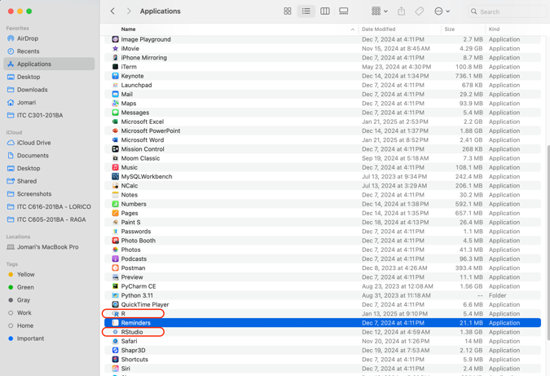 Figure 3. R and RStudio application in a MacOS

## Launching the RStudio Environment

After successful installation, you may launch the RStudio environment to start with R. Figure 4 shows how the RStudio environment looks like.

Figure 4. RStudio Environment

Figure 5. RStudio, showing the menu ribbon in an MacOS device

## The actual interface may vary, depending on the device’s operating system. However, here are the four panes that should see, as shown in Figure 4.

* Source Editor – allows users to view and edit various codes
* Console Pane – provides an area to execute the codes interactively
* Environment Pane – includes Environment, History, Connections, and Tutorials
* Files/Plot/Packages/Help – contains multiple tabs which are:
  + Files – mirrors the directory in your device to browse documents/folders
  + Plot – area where visual analysis such as histograms, etc. are displayed
  + Packages – shows list of installed packages
  + Help – access support and knowledge-base articles

# Testing Commands In RStudio

After successfully installing R and RStudio, we put the application to the test. By using a Rdata file sample, we run a series of commands in the Console Pane. See results as show in the figures below.

Figure 6. Testing commands in RStudio (a).

Figure 7. Testing commands in RStudio (b).

Figure 8. Testing commands in RStudio (c).

During the first command, *>setwd(“"),* an error was encountered – *Error: unexpected invalid token in "setwd(“"*. Subsequent commands also encountered various errors such as:

* > load( "aflsmall.Rdata" ) – Error in readChar(con, 5L, useBytes = TRUE) : cannot open the connection  
  In addition: Warning message:  
  In readChar(con, 5L, useBytes = TRUE) :cannot open compressed file 'aflsmall.Rdata', probable reason 'No such file or directory'
* > print(afl.margins) – Error: object 'afl.margins' not found
* > mean(x=afl.margins) – Error: object 'afl.margins' not found

Most of the commands tested contained the error that the object could not be found. To address this, we went back to the first command that was tested. The *>setwd(“")* command did not work because of a syntax error. The *>setwd* command is used to set the working directory of the session, and it should follow the format *>setwd(dir).*

To know the working directory of the session, use the command *>getwd()*. Loading the sample Rdata file did not work because Rdata file was located in a different folder. In this case, the Rdata was saved in the downloads folder. The Rdata file has to be moved to the same directory as the session directory in order for it to work. After moving both the sample Rdata file, and the session directory into the same location, succeeding tests conducted worked, as shown in Figure 8, and Figure 9.

# Help & Resources

Running across errors and getting lost are to be expected when you are learning a new programming language. As such, knowing where to get help is a helpful tip that both new users and professionals alike may find beneficial. Below are list of websites and resources that may come in handy:

* CRAN – The repository for everything R. Treat this as you R Bible. URL: <https://cran.r-project.org/>
* Help Tab – This is built inside the RStudio environment which contains links to various resources that will help you learn and master R.
* R on Stack Overflow – an online community of R programmers – beginners and professionals alike. URL: <https://stackoverflow.com/questions/tagged/r>
* RStudio Github Repository – an online platform for hosting and sharing open-source projects and resources related to R.

URL: <https://github.com/rstudio>

# Summary

Learning a new programming language can be quite intimidating. However, with enough dedication and determination, one can succeed in mastering R. With a multitude of resources and online communities available, getting the necessary should be easily accessible, especially in today’s time.

##### References

1. R Core Team, The Comprehensive R Archive Network (CRAN). Accessed: Jan. 26, 2025. [Online]. Available: <https://cran.r-project.org/>.
2. DataCamp, All About R: A Comprehensive Overview. Accessed: Jan. 25, 2025. [Online]. Available: <https://www.datacamp.com/blog/all-about-r>.
3. R. Peng, R Programming for Data Science: History and Overview of R. Accessed: Jan. 25, 2025. [Online]. Available: <https://bookdown.org/rdpeng/rprogdatascience/history-and-overview-of-r.html#what-is-r>.