The Dynamics of Listed Establishments in the Philippine Manufacturing Sector — Insights from the Past and Potential of the Future

Jomari Manto   
*College of Computer Studies & Engineering*  
*Jose Rizal University*Mandaluyong City, Philippines  
[jomari.manto@my.jru.edu](mailto:jomari.manto@my.jru.edu)

Blanzy Gwyneth Faith N. Cinco   
*College of Computer Studies & Engineering*  
*Jose Rizal University*Mandaluyong City, Philippines  
[blanzygwynnethfaith.cinco@my.jru.edu](mailto:blanzygwynnethfaith.cinco@my.jru.edu)

***Abstract*—This research investigates the structural dynamics of the Philippine manufacturing sector by analyzing the number of listed manufacturing establishments over time. Utilizing linear regression and predictive modeling, the study examines current trends and identifies key factors influencing the changes in establishment numbers within this specific area of the sector. Drawing on historical data obtained through the Philippine Government’s Freedom of Information (FOI) system, the study aims to: (1) uncover patterns that define the trajectory of business establishments in the manufacturing industry; (2) extract insights into the real-world implications of these trends; and (3) identify potential issues while offering practical recommendations to support sectoral growth. Ultimately, this research underscores the relevance of this specific subset of the manufacturing sector and its potential contribution to national economic development. (***Abstract***)**

***Keywords—Philippine manufacturing sector, trends in the Philippine manufacturing, Manufacturing data MSMEs Philippines, Manufacturing industry establishment prediction, Manufacturing sector statistical analysis Philippines (****keywords****)***

# Introduction

## *Background of the Study*

The manufacturing industry plays a vital role in a country’s economic development. Despite facing numerous global challenges and setbacks over the years, it continues to be a cornerstone of economic growth. Su and Yao [1] demonstrated that advancements in manufacturing can generate ripple effects across other sectors by enhancing human capital—through skills, knowledge, experience, and education—as well as strengthening economic institutions, such as laws, regulations, and structural frameworks. This underscores the manufacturing sector’s enduring status as a key engine of economic progress.

Khan and Siddiqi [2] in their research focused in Pakistan were able to confirm the strong positive relationship of the manufacturing sector and Pakistan’s Gross Domestic Product (GDP), which further supports the notion that manufacturing is an engine for economic growth.

In the context of the Philippines, the manufacturing industry contributed approximately ₱3.78 trillion to the country’s 2023 Gross Domestic Product (GDP), making it the second largest economic sector. According to Statista, semiconductors and other electronics remain the country’s top manufacturing exports, underscoring the sector’s strong role in supporting trade performance and sustaining industrial output [3]. Beyond electronics, the sector also includes vital industries such as food processing, chemicals, textiles, and construction materials, which supply both domestic needs and international markets. This broad base allows manufacturing to serve as a pillar for job creation, supply chain development, and technological advancement.

Despite this milestone and contributions, the Philippine sector continues to face drawbacks due to various factors.

## *Statement of the Problem*

Various studies have explored the challenges confronting the Philippine manufacturing sector. Aldaba [4], through an analysis of multiple performance indicators, highlights the sector’s stagnant growth over time. Statista [2] also identifies a heavy reliance on imported raw materials as a persistent issue, which contributes significantly to recurring trade deficits. Additionally, the Monthly Integrated Survey of Selected Industries (MISSI) published by the Philippine Statistics Authority (PSA) on April 8, 2025, reports a decline in two key indicators—Value of Production Index (VaPI) and Value of Net Sales Index (VaNSI)—further signaling a slowdown in sector performance [4]. Supporting this, a report by Christy Balita documents a consistent decline in the number of manufacturing establishments from 2016 to 2022 [5].

While it is recognized that multiple interrelated factors affect the overall performance of the manufacturing sector—including production output, export levels, and labor dynamics—this research will specifically focus on the number of listed establishments (LE). The LE serves as a structural indicator of industrial activity, representing not just current output but also the capacity, presence, and resilience of the manufacturing base over time. A declining number of establishments may reflect broader systemic issues such as reduced investor confidence, cost inefficiencies, or policy gaps. By analyzing historical LE data, this study will identify patterns and potential predictors that can explain this trend and generate forecasts to inform strategic planning and policymaking. In doing so, the research contributes to a more grounded understanding of how the structural composition of the sector is evolving.

## *Hypotheses of the Study*

## The Philippine Statistics Authority classifies manufacturing establishments into four categories based on total employment. The categories of LEs are as follows:

## Micro: 1 to 9 employees

## Small: 10 to 99 employees

## Medium: 100 to 199 employees

## Large: 200 or more employees

Based on these categories, the hypotheses of these research are as follows:

**Ho1:** The micro-scale manufacturing sector (1–9 employees) comprises the majority of manufacturing establishments in the Philippines, reflecting the dominance of small-scale industrial activities.

**Ho2:** The small-scale manufacturing sector (10–99 employees) shows a steady presence across regions, suggesting its role as a backbone of local industrial development.

**Ho3:** The number of medium-scale manufacturing establishments (100–199 employees) remains limited, indicating potential barriers to enterprise growth beyond the small-scale level.

**Ho4:** The large-scale manufacturing sector (200 or more employees) accounts for the fewest number of establishments, emphasizing the challenges in scaling operations to a large employment size.

Lastly, in conjunction with our problem statement, the fifth hypothesis is:

**Ho5:** The overall number of manufacturing establishments in the Philippines has been declining over time, suggesting a downward trend in the growth of the sector.

*D. Scope and Limitation of the Study*

This study focuses solely on the number of listed establishments (LE) in the Philippine manufacturing sector as the main indicator of structural performance. While other metrics such as production output, exports, and employment are relevant, they are not included in the scope of this research. The choice to focus on LE is based on its value as a measurable indicator of the sector’s capacity and continuity over time.

The analysis is limited by the availability of historical data, which was sourced from official government records. As such, the number of observations depends on the completeness and consistency of the published data. External factors and qualitative variables influencing the sector are beyond the scope of this study and are not accounted for in the analysis.

## *E. Significance of the Study*

This study is significant to ordinary Filipinos as it seeks to raise awareness of the importance of supporting the country’s domestic manufacturing sector. By shedding light on its role in economic development, job creation, and national resilience, the research encourages Filipinos to make more informed choices—such as patronizing local products, advocating for stronger industrial policies, and actively contributing to the sector’s growth and sustainability.

# Methodology

# *Data & Analytics Techniques*

# This research utilizes official data on the number of listed establishments in the Philippine manufacturing sector. The dataset was provided by the PSA FOI Team upon the researcher’s request (Reference No. FOI-REQ-2025-3951). It includes raw data on the number of establishments by region, section, and employment groupings (Micro, Small, Medium, Large) in the Philippines from 1993 to 2023, along with information from other sectors such as agriculture and fisheries.

## For the purpose of this study, data specific to the manufacturing sector was extracted and organized into a final dataset containing the following variables:

1. DataFrame Variables And Descriptions

| **Variable** | **Description** |
| --- | --- |
| Year | Reference year (1999–2023) |
| Total | Total number of listed manufacturing establishments |
| Micro | Number of micro establishments (1–9 employees) |
| Small | Number of small establishments (10–99 employees) |
| Medium | Number of medium establishments (100–199 employees) |
| Large | Number of large establishments (200+ employees) |

1. Data frame variables and descriptions.

## To capture the current dynamics of the data, descriptive analytics through Exploratory Data Analysis (EDA) was employed. In addition, predictive analytics using linear stepwise regression was applied to model and forecast future trends.

# *Exploratory Data Analysis (EDA)*

## As a prerequisite for linear regression, stepwise regression, and predictive modeling, exploratory data analysis (EDA) was applied to the dataset. The objectives are as follows:

## Identify the trend in the total number of establishments from 1999 to 2023

## Detect outliers or significant changes over time

## Examine the distribution and proportion of establishments by size category

## Identify significant relationships between each category vs total number of establishments

## Assess datasets' readiness for regression modeling.

The following tables and figures illustrate the results of the EDA and their significance in the context of the research problem statement.

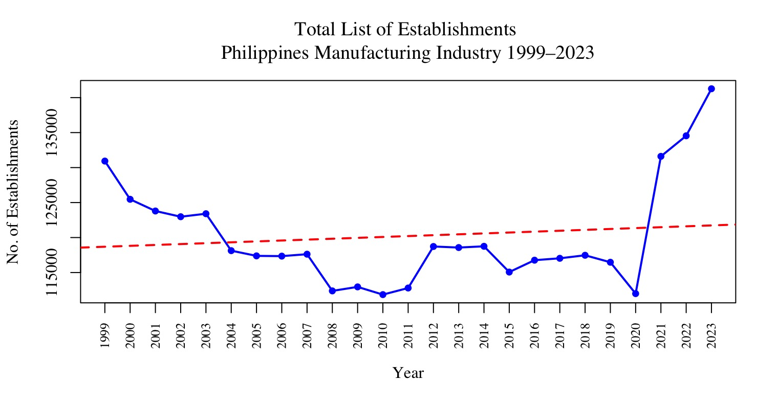

1. Data frame variables and descriptions.

## Fig. 2 shows the trend of listed manufacturing establishments from 1999 to 2023. The red dashed trend line reflects minimal upward movement, indicating stagnant growth in the number of establishments within the industry.

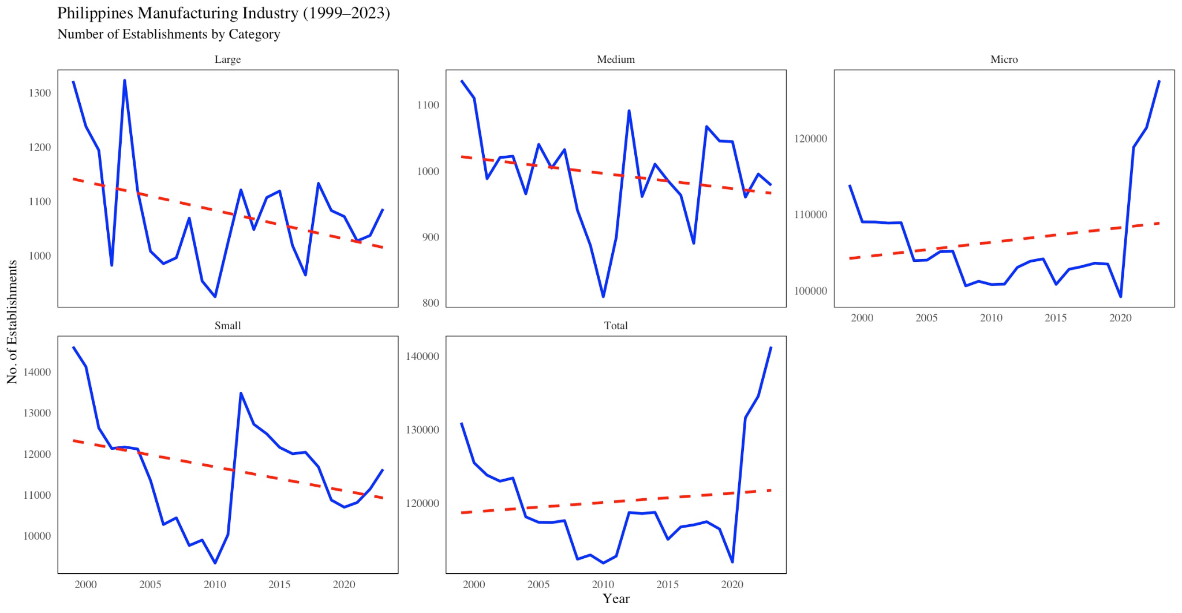

1. Trend of Listed Manufacturing Establishments in the Philippines (1999–2023) per Category

## Fig. 3 shows the trend of listed manufacturing establishments by category from 1999 to 2023. Except for Micro establishments (first row, third column), all categories—Small, Medium, and Large—exhibit a decline in numbers. Overall, these illustrations highlight a clear downward trend in the number of listed establishments.

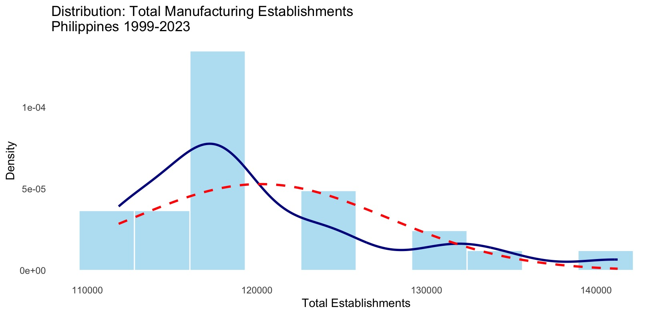

1. Distribution of Total Manufacturing Establishments in the Philippines (1999–2023)

## Fig. 4 shows the number of manufacturing businesses in the Philippines from 1999 to 2023. Most years had between 117,000 and 122,000 establishments, with fewer years having much higher numbers. This means the average is pulled up by a few outliers, but in general, the number of businesses stayed on the lower side. This distribution suggests that manufacturing growth in the Philippines has been uneven, likely influenced by structural fluctuations or sectoral instability over time.

## 

1. Box Plot of Manufacturing Establishments in the Philippines by Total and Size Categories (1999–2023)

## Fig. 5 presents box plots of manufacturing establishments in the Philippines from 1999 to 2023, showing the total, and size categories.The box plots reveal several trends in the number of businesses over the years. First, there were more years with fewer businesses, especially for smaller establishments, as shown by the boxes being pushed toward the top, indicating most numbers were on the lower side. However, some years saw spikes in the number of small businesses, marked by dots above the normal range. For medium and large businesses, the data was more steady, with smaller and more stable boxes, and fewer surprising jumps. Micro businesses, on the other hand, dominated in terms of numbers, with their values reaching over 110,000, making them the largest group. Lastly, large businesses remained small and steady, with little change over the years, reflected by a tight, low box in the plot.

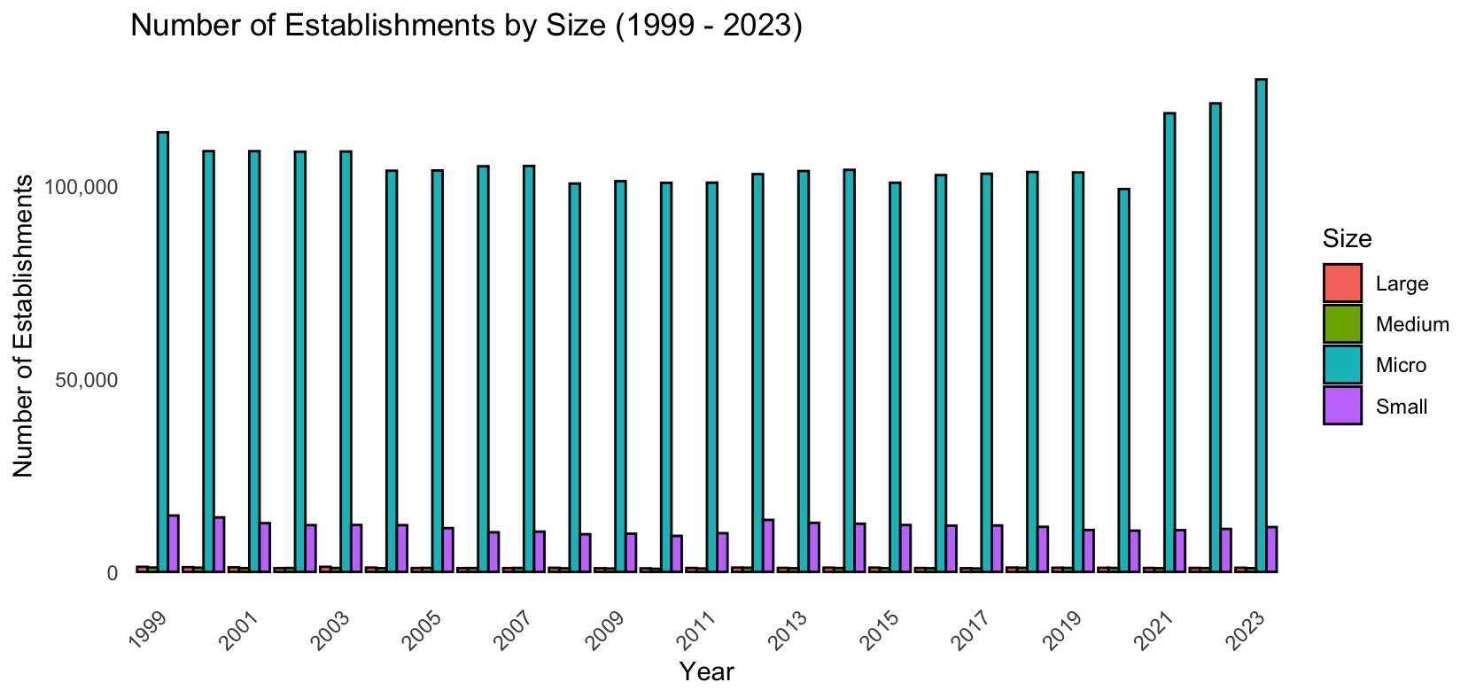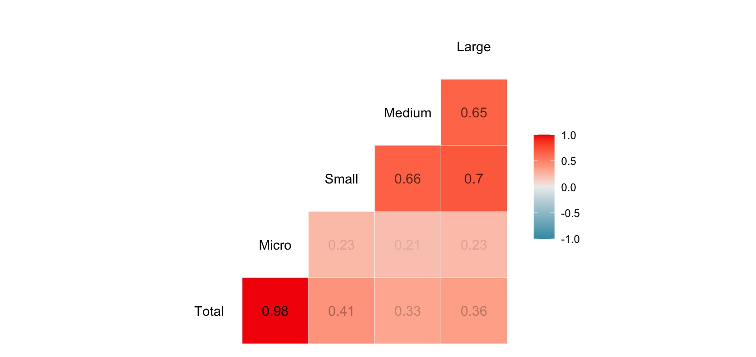

1. Side-by-Side Bar Chart of Philippine Manufacturing Establishments by Size (1999–2023) & Correlation Matrix

## Fig. 6 shows the dominance of micro establishments, suggesting their significant influence on the total number of manufacturing establishments in the Philippines. The bar charts highlight the towering height of the Micro category compared to the Small, Medium, and Large categories. Meanwhile, the correlation matrix indicates that the Micro category has the strongest positive relationship with the total number of listed establishments, with a correlation value of 0.98.

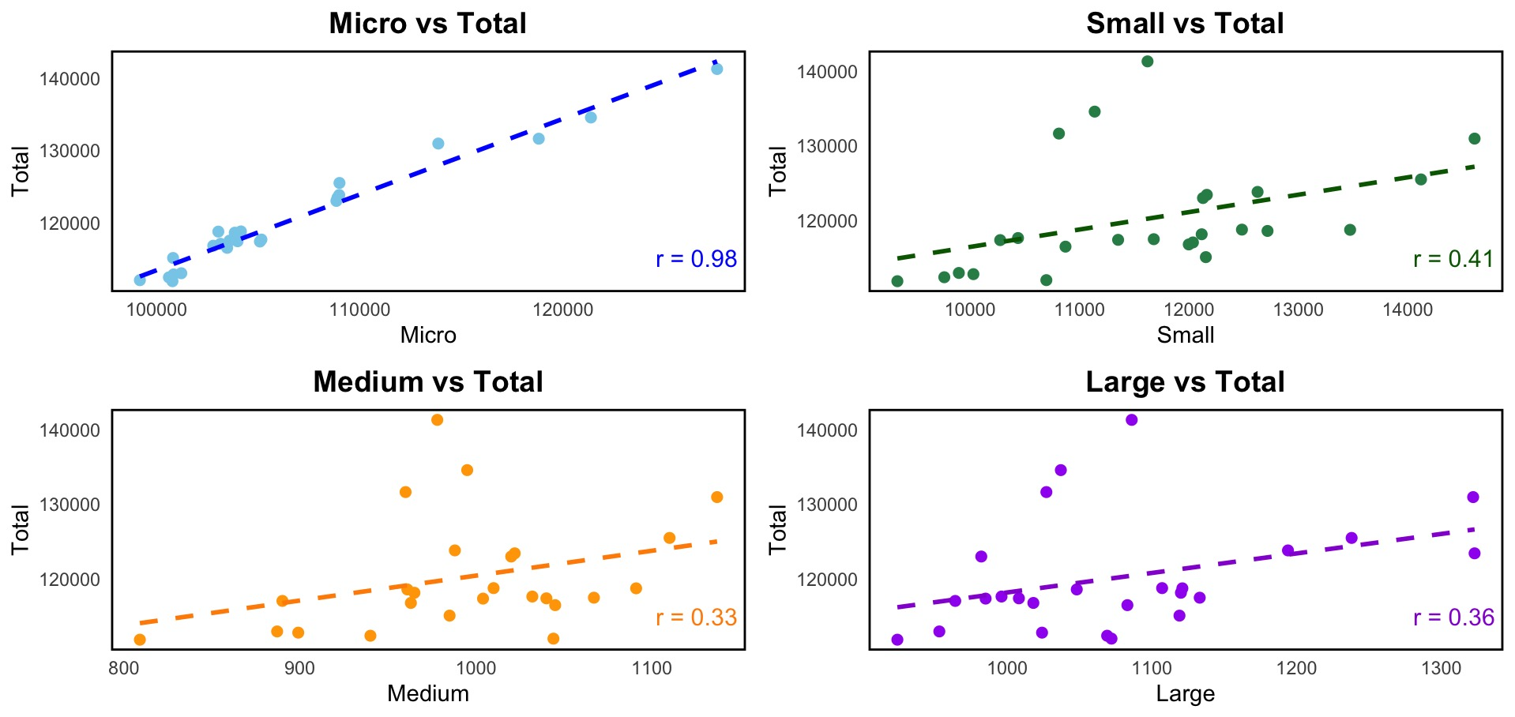

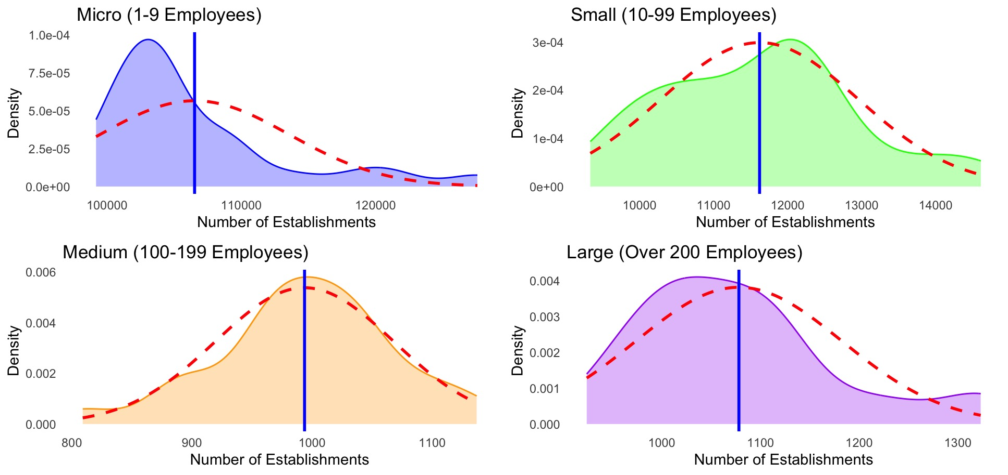  
Fig. 7. Side-by-Side Bar Chart of Philippine Manufacturing Establishments by Size (1999–2023) & Correlation Matrix

Fig. 7 shows both scatter plots and density plots. The scatter plots illustrate the linear relationship between each size category and the total number of listed establishments. Among them, the Micro category shows the strongest positive relationship, backed by a high correlation value of 0.98 and a tight clustering of data points along the trendline. This means that the number of micro establishments closely follows the overall trend with little variation. Meanwhile, the density plots show how the values are distributed. The Small, Medium, and Large categories appear closest to a normal distribution, with curves that are fairly symmetrical. In contrast, the Micro category is right-skewed, meaning most of its values fall below the mean, with fewer but higher values stretching the curve to the right.

## In summary, our Exploratory Data Analyses have provided the following:

## Trend of the Data: There is a downward trend in the total number of listed establishments over time..

## Linear Relationship: A strong positive linear relationship was found between the different size categories and the total number of establishments, with the Micro size category showing the most significant relationship to the total.

1. Data Distribution: Although the data is not perfectly normally distributed, it exhibits sufficient normality for it to be considered appropriate for linear regression modeling.

# *Predictive Modeling through Linear Regression (Stepwise)*

This section outlines the process of building the predictive model, starting with variable selection, followed by the creation of a base model, application of stepwise regression to refine the model, and concluding with model selection, testing, and evaluation.

The response variable is Total, while the predictor variables are the size categories: Micro, Small, Medium, and Large.

For the initial linear regression base model, all predictor variables were included and processed in R using the *lm()* function.

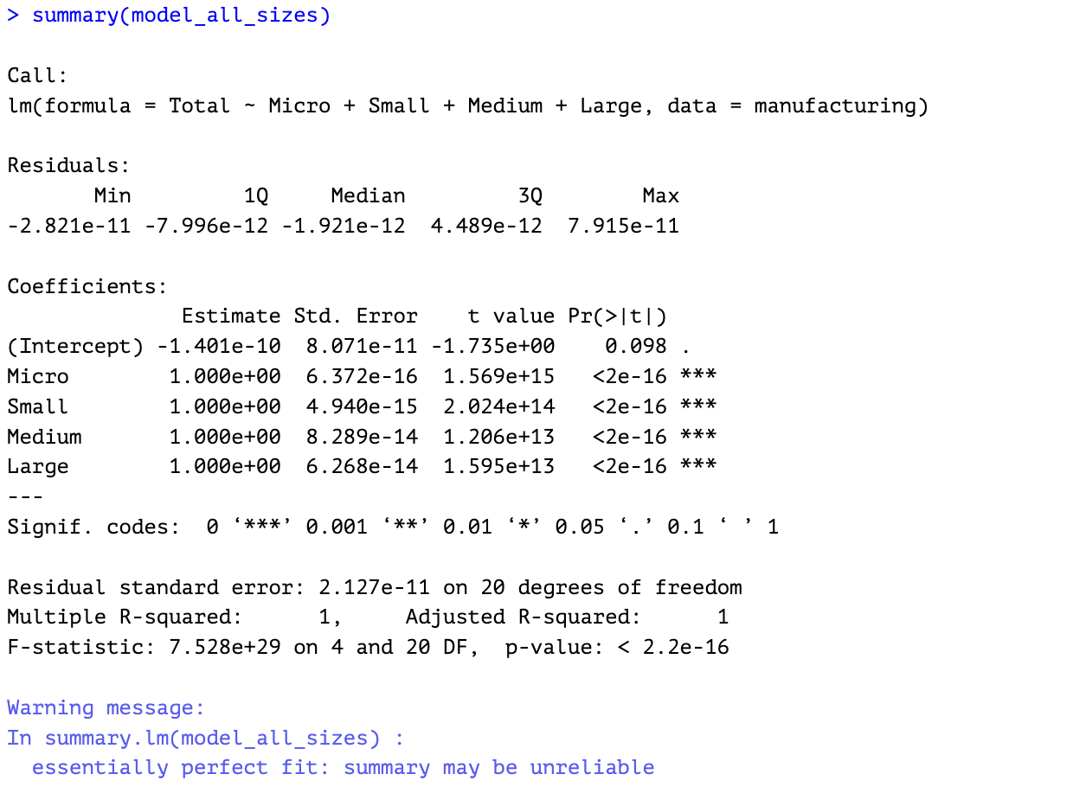

Fig. 8. Summary of Linear Base Model Using All Predictors.

The results of our initial model show that all the size categories (Micro, Small, Medium, Large) are important predictors, and they have a strong relationship with the total number of establishments. The model has very small errors, and the R-squared value is 1, meaning it fits the data almost perfectly.

However, this perfect fit can be a red flag because it might mean the model is too closely matched to the current data and may not work as well with new data.

The Adjusted R-squared value, which adjusts for the number of predictors in the model, is also 1, confirming that the model is overly tailored to the data. Additionally, the very low p-values (less than 0.001) suggest that the predictors are statistically significant, meaning they are likely important, but this doesn’t guarantee the model’s effectiveness outside the current dataset.

To make sure the model works well with new data and to focus on the most important predictors, stepwise regression will be used. This approach will help improve the model by selecting only the most significant factors, ensuring the final model is simpler and more reliable.

Stepwise regression will be applied in the following order:

Backward — eliminating the least significant predictors one-by-one on the base model.

Forward — iteratively adding predictors to a null model, i.e. the model is created using the coefficient only, without any predictors.

Bidirectional — simultaneously adding and removing predictors to the model of the data set.

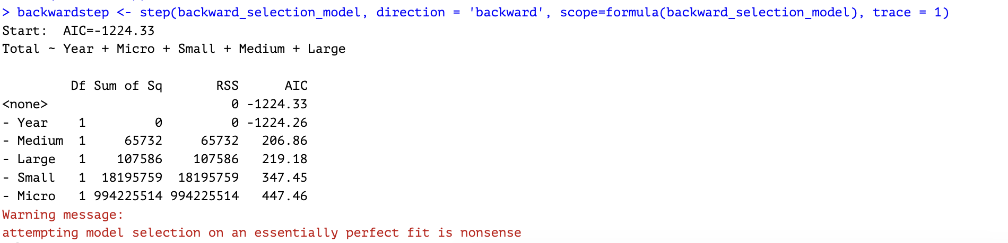

Fig. 9. Results of Backward Elimination Using *step()* Function

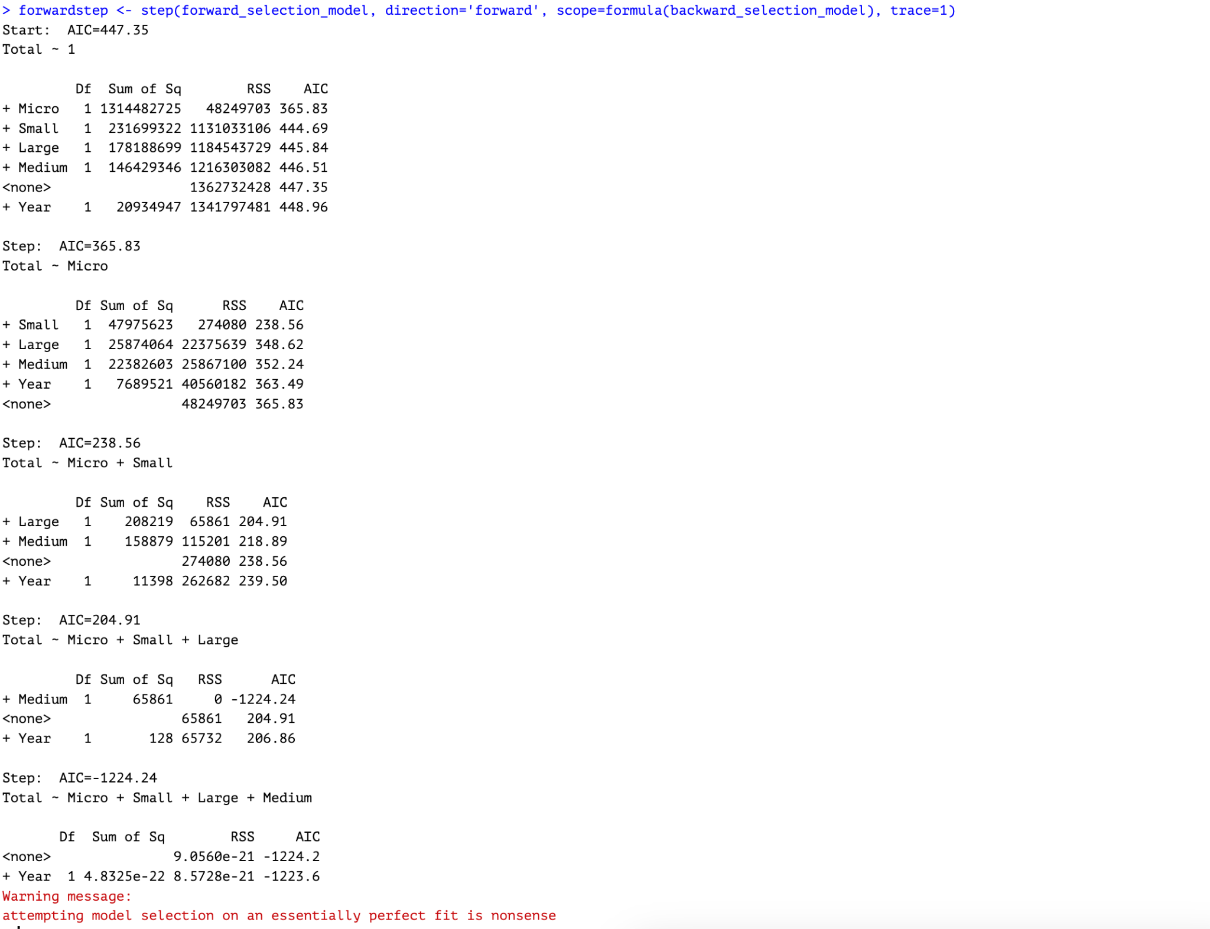

Fig. 10. Results of Forward Selection Using *step()* Function

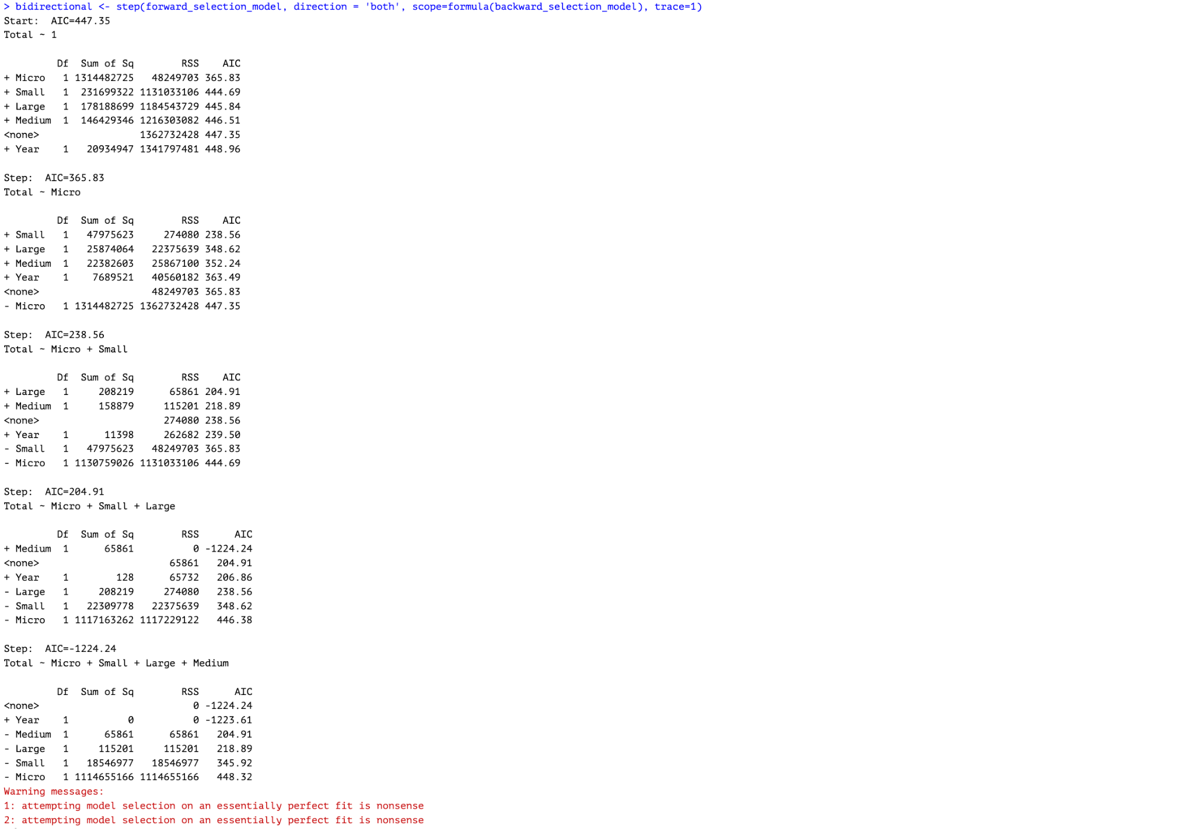

Fig. 11. Results of Bidirectional Elimination Using *step()* Function

Figures 9, 10, and 11 show the results of the stepwise regression analysis conducted using the *step()* function in R. The models used are stored in the variables *backward_selection_model* (the model including all predictors for the Total variable) and *forward_selection_model* (the model created based on coefficients alone, without including any predictors).

In an ideal scenario, stepwise regression is expected to iteratively add or remove predictor variables in order to refine the model and retain only those that contribute significantly to predicting the response variable. However, in this case, the stepwise regression process—whether performed in a forward, backward, or bidirectional manner—ultimately retained all predictors (Micro, Small, Medium, and Large) in the final model. This lack of variable elimination suggests that all predictors are strongly correlated with the response variable.

Furthermore, R consistently issued the following warning message during the model selection process:



Fig. 12. Warning message, indicating that the model is overfitting, and may be unreliable.

This warning is a clear indication of overfitting, where the model fits the dataset too perfectly, potentially compromising its ability to generalize to new data.

Table II. Comparison of Model Assessment Criteria Across Stepwise Regression Methods

| **Metric** | **Backward Selection** | **Forward Selection** | **Bidirectional Selection** |
| --- | --- | --- | --- |
| Model | Total ~ Micro + Small + Medium + Large | Total ~ Micro + Small + Large + Medium | Total ~ Micro + Small + Medium + Large |
| MSE (Mean Squared Error) | 9.06E-21 | 0.0 (final step: perfect fit) | 0.0 (final step: perfect fit) |
| RMSE (Root MSE) | 3.01E-11 | 0.0 (very small) | 0.0 (very small) |
| R-squared | 1.00 (Perfect Fit) | 1.00 (Perfect Fit) | 1.00 (Perfect Fit) |
| Adjusted R-squared | 1.00 (Perfect Fit, but unreliable) | 1.00 (Perfect Fit, but unreliable) | 1.00 (Perfect Fit, but unreliable) |
| AIC | -1224.33 | 365.83 (first step, Micro only) | 447.35 (initial null model) |
| Final Model | Total ~ Micro + Small + Medium + Large | Total ~ Micro + Small + Large + Medium | Total ~ Micro + Small + Medium + Large |

Fig. 13. Performance of the three stepwise regression methods.

The final model from the stepwise regression retained all predictors, suggesting that each variable significantly contributes to explaining the total number of listed establishments. However, the model has already been identified as overfitted and therefore unreliable, highlighting the need to explore alternative modeling approaches.

Before exploring alternative models, a final check will be conducted to calculate the Variance Inflation Factor (VIF) to check for multicollinearity among the predictors that may help explain the results.

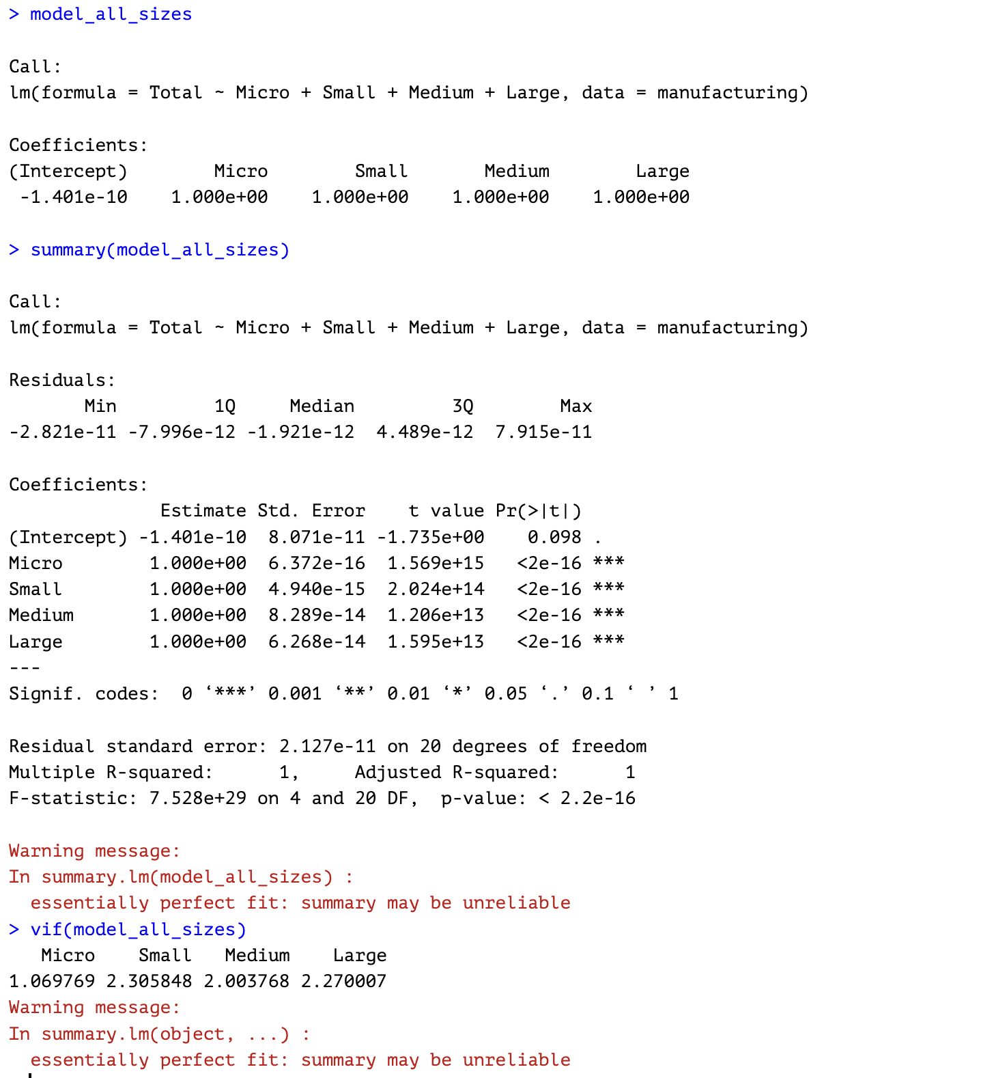

Fig. 14. Checking for multicollinearity using *vif()* function in R.

Table III. Vif Values Of Predictors

| **Predictor** | **VIF Value** | **Interpretation** |
| --- | --- | --- |
| Micro | 1.07 | No multicollinearity concern |
| Small | 2.31 | Low multicollinearity |
| Medium | 2 | Low multicollinearity |
| Large | 2.27 | Low multicollinearity |

Fig. 15. Summary and interpretation of VIF results.

The results show that there is no multicollinearity to low multicollinearity with the predictors. Yet, the model is still not reliable due to overfitting.

In this section, we examine our Exploratory Data Analysis results, which show that the Micro category exhibits the strongest positive linear relationship with the response variable, Total.

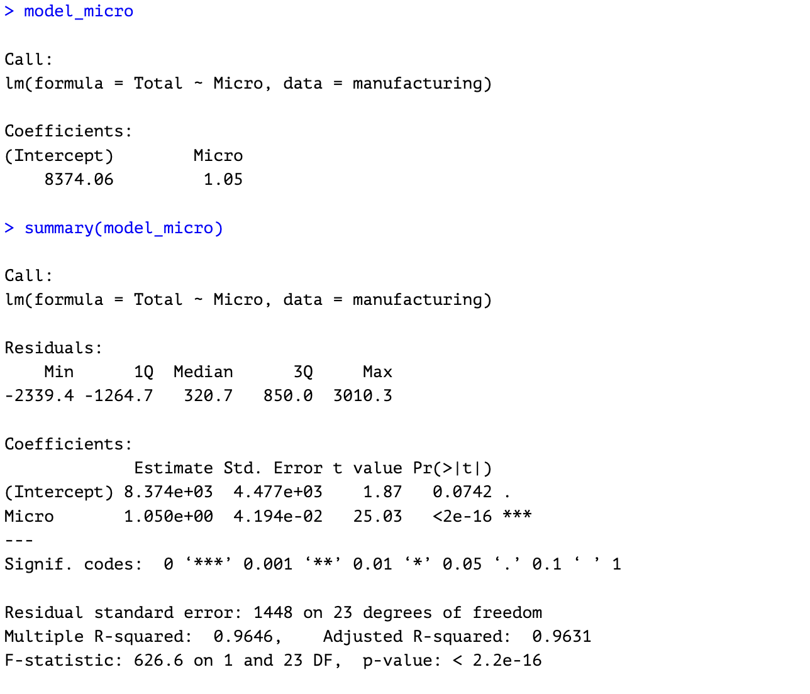

Fig. 16. Summary of Selected Model, using Micro as predictor for Total.

The linear regression equation based on the selected model is:

*Total Establishments = 8,374.06 + 1.05 × (Micro Establishments)*

The model indicates that each additional micro establishment is associated with an estimated increase of 1.05 in the total number of manufacturing establishments, reinforcing the strong linear relationship between micro-scale activity and total sector presence. When there are (hypothetically) zero micro establishments, the model predicts 8,374 total establishments. This intercept is likely a modeling artifact, as micro establishments are consistently present in the manufacturing sector and their absence is not a plausible scenario.

## *D. Testing the Model*

## Due to the limited availability of data, all observations were used in the creation of the model. To assess the reliability of the model, a prediction method will be employed, where the predicted values will be compared to the actual observed values.

## This will allow us to evaluate the accuracy and performance of the model in forecasting the total number of listed establishments in the Philippines' manufacturing sector.

Table IV. Actual Values, Predicted Total, & Percent Error

| **Year** | **Actual Total** | **Predicted Total** | **Percent Error** |
| --- | --- | --- | --- |
| 1999 | 130,931 | 127,921 | 2.30% |
| 2000 | 125,467 | 122,815 | 2.11% |
| 2001 | 123,795 | 122,802 | 0.80% |
| 2002 | 122,977 | 122,656 | 0.26% |
| 2003 | 123,406 | 122,710 | 0.56% |
| 2004 | 118,127 | 117,490 | 0.54% |
| 2005 | 117,382 | 117,548 | -0.14% |
| 2006 | 117,346 | 118,704 | -1.16% |
| 2007 | 117,622 | 118,782 | -0.99% |
| 2008 | 112,377 | 114,003 | -1.45% |
| 2009 | 112,950 | 114,642 | -1.50% |
| 2010 | 111,846 | 114,185 | -2.09% |
| 2011 | 112,789 | 114,246 | -1.29% |
| 2012 | 118,722 | 116,556 | 1.82% |
| 2013 | 118,572 | 117,405 | 0.98% |
| 2014 | 118,749 | 117,723 | 0.86% |
| 2015 | 115,068 | 114,218 | 0.74% |
| 2016 | 116,766 | 116,294 | 0.40% |
| 2017 | 117,035 | 116,670 | 0.31% |
| 2018 | 117,468 | 117,137 | 0.28% |
| 2019 | 116,470 | 117,012 | -0.47% |
| 2020 | 111,988 | 112,502 | -0.46% |
| 2021 | 131,604 | 133,113 | -1.15% |
| 2022 | 134,542 | 135,807 | -0.94% |
| 2023 | 141,266 | 142,326 | -0.75% |

Fig. 17. Comparison of actual vs predicted values of Total Listed Establishments using the selected model.

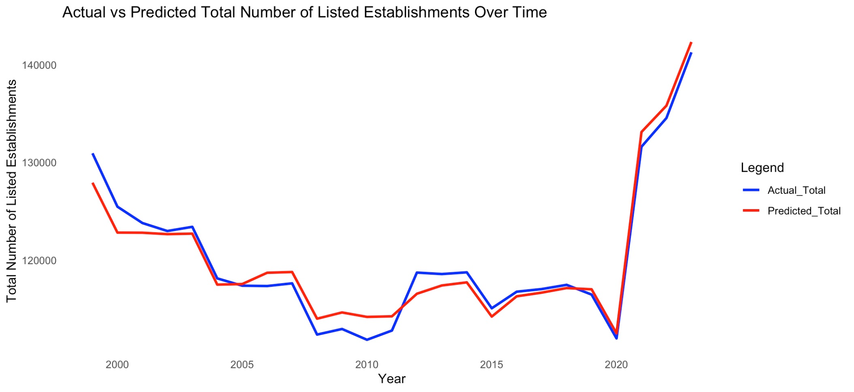

Fig. 18. Time Series Graph, comparing the values of predicted data vs actual data (Total Listed Establishments)

Figures 17 and 18 display the comparison on actual value vs the predicted value. In evaluating the forecasting model's performance, the average percent error was calculated to be approximately -0.02%. This indicates that, on average, the model's predictions slightly overestimate the actual values. The near-zero average error reflects the model's high accuracy in forecasting, with only minimal bias. This insight is valuable for understanding the model's predictive behavior and can guide further refinements to enhance forecasting precision.

# III. Discussion of Findings

This section delves into the implications of the research findings and revisits the study's hypotheses. By interpreting the results, we aim to understand their significance and how they contribute to the existing body of knowledge. Additionally, we will assess whether the findings support or challenge the initial hypotheses, providing a comprehensive analysis of the study's outcomes

## *Revisting the Hypotheses of the Study*

***Ho1:*** *The micro-scale manufacturing sector (1–9 employees) comprises the majority of manufacturing establishments in the Philippines, reflecting the dominance of small-scale industrial activities.*

The research results confirm that the initial assumption was correct, as shown in Figure 6. This means that the model's predictions were accurate and aligned with the actual data, supporting the hypothesis made at the beginning of the study.​

***Ho2:*** *The small-scale manufacturing sector (10–99 employees) shows a steady presence across regions, suggesting its role as a backbone of local industrial development.*

The research results indicate that small-scale manufacturing businesses have a minimal impact on the overall growth of all manufacturing establishments. This conclusion is supported by Figures 6 and 7, which show a correlation value of only 0.41. A correlation of 0.41 suggests a weak positive relationship, meaning that as small-scale manufacturing establishments increase, the growth in the total number of manufacturing establishments also increases slightly, but the effect is not strong.

***Ho3:*** *The number of medium-scale manufacturing establishments (100–199 employees) remains limited, indicating potential barriers to enterprise growth beyond the small-scale level.*

The research findings indicate that the number of medium-scale manufacturing businesses (those with 100–199 employees) has decreased over time. This trend is clearly depicted in Figure 3, which shows a consistent decline in establishments within this category.

***Ho4:*** *The large-scale manufacturing sector (200 or more employees) accounts for the fewest number of establishments, emphasizing the challenges in scaling operations to a large employment size.*

The research findings indicate that large-scale manufacturing businesses, defined as those with 200 or more employees, represent a relatively small portion of the total manufacturing establishments. With an average of 1,078.12 establishments, they have the second-lowest number, following medium-scale establishments, which average 993.68 establishments. This is supported by the descriptive summary statistics of the data set included in the appendix of this research.

***Ho5:*** *The overall number of manufacturing establishments in the Philippines has been declining over time, suggesting a downward trend in the growth of the sector.*

The research findings indicate that the number of manufacturing establishments in the Philippines declined from 1999 to 2020. However, starting in 2020, there was an upward spike in the data, suggesting a period of stagnant growth rather than a continued decline. This is illustrated in Figure 2 of this research.

Table V. Summary of Hypotheses Evaluation

| **Hypothesis** | **Evaluation** |
| --- | --- |
| *Ho1* | True |
| *Ho2* | Partially True |
| *Ho3* | True |
| *Ho4* | False |
| *Ho5* | Partially False |

## *Summary and Significance of Findings in the Context of the Domain*

This research has identified both the strengths and weaknesses in the dynamics of listed establishments within the Philippine manufacturing sector. A significant highlight is the noticeable increase in the number of listed establishments from 2020 onwards, indicating positive growth for the sector. If this momentum is maintained, it could substantially contribute to the Philippines' economic progress, including its GDP. However, the data also reveals that, despite recent advancements, the sector experienced a prolonged period of decline prior to 2020. Furthermore, three out of the four categories lag significantly behind the micro-size category. This reinforces the structural barriers faced by micro enterprises in transitioning to small- or medium-scale operations, potentially due to constraints in financing, market access, or regulatory burden. While the number of listed establishments serves as a key indicator of the manufacturing sector's performance, its impact extends beyond mere numbers. A decline in these establishments can signal a reduction in production levels, employment opportunities, and overall economic contribution. Such a downturn may adversely affect the sector's contribution to the Philippines' economic progress, including its Gross Domestic Product (GDP).

Therefore, monitoring and addressing the dynamics of listed establishments is crucial for sustaining the sector's role in national economic development.​

# IV. Conclusion & Reflection

This research has provided a clearer picture of the current landscape of the Philippine manufacturing sector by focusing on the trends in the number of listed establishments. The findings reveal that micro-scale enterprises remain dominant, while small-, medium-, and large-scale establishments continue to represent a significantly smaller portion of the sector. This imbalance highlights persistent challenges in scaling operations and sustaining long-term industrial growth. Despite a prolonged period of decline prior to 2020, the recent increase in listed establishments suggests early signs of recovery and revitalization.

The implications of these findings extend beyond academic relevance. In reality, this trend reflects structural limitations—such as limited access to capital, technological constraints, and workforce gaps—that hinder many Filipino manufacturers from growing beyond the micro scale. Although the government has already introduced several strategic programs aimed at strengthening the sector, these efforts can only go so far without the active participation of Filipino citizens.

To effectively address these challenges and capitalize on emerging opportunities, a shared responsibility must exist between the government and the public. The government can provide the policy environment, infrastructure, and institutional support, but it is equally important for citizens to support local industries, advocate for progressive policies, and actively engage in efforts to upskill and modernize the workforce. The table below shows a few examples of actions that both the Philippine government and ordinary citizens can do to promote and help our manufacturing sector.

Table VI. Actionable Recommendations

| **Government** | **Citizens** |
| --- | --- |
| Implement and fund programs like the Tatak Pinoy Act and the Philippine Development Plan 2023–2028 to promote competitiveness and industrial development [8]. | Support locally made products and businesses to increase demand for domestic manufacturing output. |
| Provide infrastructure and technological support (e.g., Advanced Manufacturing Center, or AMCen) to modernize the sector. | Participate in workforce upskilling programs and adapt to new technologies. |
| Offer incentives to MSMEs and encourage investments through tax reforms like the CREATE Law [9]. | Advocate for policy reforms that favor sustainable manufacturing and inclusive growth. |
| Promote regional industrialization and innovation hubs. | Educate fellow citizens about the importance of manufacturing and economic resilience. |

Lastly, while this study was able to capture important structural trends and create a forecasting model through the methodologies of descriptive and predictive analytics, it is limited by the scope of its variables. The number of listed establishments, though informative, does not capture all external factors such as global economic shifts, market demands, or policy changes that may influence the sector. Future research should incorporate a wider range of indicators to gain a more comprehensive understanding of the manufacturing industry. Nevertheless, this study can serve as a critical starting point in developing informed and inclusive strategies to revitalize the Philippine manufacturing sector.

# Acknowledgements

The students acknowledge the sources of instructional and technical support that contributed to the successful completion of this activity. The same support was also instrumental in previous related tasks, and continued assistance is sincerely appreciated. Sincere gratitude is extended to the following:

**The Creator** for the gift of life and abilities—still a work in progress, yet central to the pursuit of learning and future opportunities.

**Rodolfo C. Raga Jr., PhDCS**, for his insightful feedback and for encouraging the exploration of ideas beyond conventional limits.

**Innovators and technologists** whose tools and platforms have enabled efficient data processing, analysis, and visualization throughout this activity.

**Researchers and academics** whose foundational work and published insights guided the direction of this research.

**Readers and peers** for their time and constructive feedback; and

**AI-based tools like ChatGPT**, which served as a supplemental resource for clarification, troubleshooting, and support throughout the research process.

Appendix

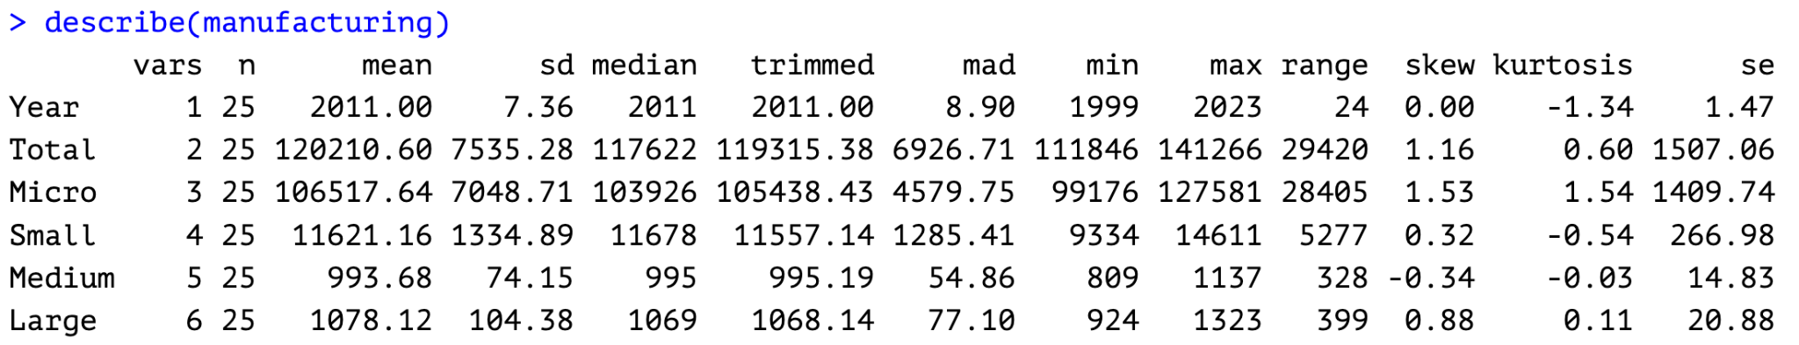

Fig. A1. Descriptive Statistics of the Data Set

References

1. D. Su and Y. Yao, “Manufacturing as the key engine of economic growth for middle-income economies,” Asian Development Bank Institute (ADBI), Working Paper No. 573, May 2016. [Online]. Available: <https://www.adb.org/publications/manufacturing-key-engine-economic-growth-middle-income-economies/>
2. K. S. Khan and M. W. Siddiqi, “Impact of manufacturing industry on economic growth in case of Pakistan: A Kaldorian approach,” SSRN Electronic Journal, Sep. 2011. [Online]. Available: <https://doi.org/10.2139/ssrn.1926783>
3. C. Balita, “Manufacturing sector in the Philippines - statistics & facts,” Statista, Dec. 3, 2024. [Online]. Available: <https://www.statista.com/topics/11457/manufacturing-in-the-philippines/>
4. R. M. Aldaba, The Philippine Manufacturing Industry Roadmap: Agenda for New Industrial Policy, High Productivity Jobs, and Inclusive Growth, Philippine Institute for Development Studies, Discussion Paper Series No. 2014-32, Jun. 2014. [Online]. Available: <https://pids.gov.ph/publication/discussion-paper-series/the-philippine-manufacturing-industry-roadmap-agenda-for-new-industrial-policy-high-productivity-jobs-and-inclusive-growth>
5. Philippine Statistics Authority, “Seasonally adjusted production index,” psa.gov.ph. [Online]. Available: <https://psa.gov.ph/statistics/manufacturing/seasonally-adjusted-production-index>
6. Statista Research Department, “Philippines: number of manufacturing establishments 2022,” *Statista*. [Online]. Available:<https://www.statista.com/statistics/1331181/philippines-number-of-manufacturing-establishments/>
7. Philippine Statistics Authority, “Establishments by region, section, and employment groupings (Micro, Small, Medium, Large), Philippines: 1993–2023,” Google Sheets, Apr. 2025. [Online]. Available: <https://docs.google.com/spreadsheets/u/0/d/1YJEZqBIeoW3N38eg3MlHkNX_tc3IXcrm/htmlview>
8. Republic of the Philippines, “Republic Act No. 11981: Tatak Pinoy (Proudly Filipino) Act,” Official Gazette, Feb. 26, 2024. [Online]. Available: <https://lawphil.net/statutes/repacts/ra2024/ra_11981_2024.html>
9. Republic of the Philippines, “Republic Act No. 11534: Corporate Recovery and Tax Incentives for Enterprises (CREATE) Act,” Official Gazette, Mar. 26, 2021. [Online]. Available: <https://lawphil.net/statutes/repacts/ra2021/ra_11534_2021.html>