The Declining Balance of Trade in the Philippines: Trends, Challenges, and Future Implications

Jomari Manto   
*College of Computer Studies & Engineering*  
*Jose Rizal University*Mandaluyong City, Philippines  
[jomari.manto@my.jru.edu](mailto:jomari.manto@my.jru.edu)

August Brillo  
*AUGUST, The Pomeranian*  
Kai Gardens ResidencesMandaluyong City, Philippines  
<https://www.instagram.com/august_thepomeranian/>

***Abstract*— This research explores the historical performance of the Philippines in terms of international trade of the previous thirty–four years, from 1991 to 2024. By performing Exploratory Data Analysis, data visualization, and predictive modeling with the use of linear regression, this research paper shows key findings on the trend of the Philippines’ Balance of Trade. Our key variables are as follows: (1) Exports, (2) Imports, (3) Balance of Trade, and (4) Total Trade. The key findings of this research are as follows: (1) The yearly Total Trade since 1991 to 2024 has been increasing, (2) Increasing trend in the yearly values of both Exports, and Imports with Imports showing bigger values than exports, and (3) Balance of Trade has been in decline since 1991, indicating an unfavorable trade balance for the Philippines. The implications of these findings are also discussed in the paper such as its effect on the value of the Philippine currency, inflation, and cost-of-living of the average Filipino. However, this paper also gives insights on actionable recommendations that decision–makers and future researchers may be able to use to address any drawbacks caused by the declining trend of the Philippines’ Balance of Trade. (***Abstract***)**

***Keywords—Exports, Imports, International Trade (****keywords****)***

# Introduction

## *Background of the Study*

Trade, the exchange of goods and services, dates back to the prehistoric era of the barter system. In the modern world, international trade—the cross-border movement of goods and services—has evolved beyond a mere transactional activity. It now serves as a key indicator of a country's economic standing, providing insights into whether a nation is experiencing growth, stability, or decline.

In the case of the Philippines, its participation in international trade dates back to the pre-colonial period, although it has not been given significant attention by the general public.[1] As early as the ninth century, historical accounts show that Filipinos had trade relations with countries such as China, Japan, India, and Arabia.[1]

Today, the Philippines continues to engage in global trade through treaties and partnerships with international organizations such as the World Trade Organization (WTO), the Association of Southeast Asian Nations (ASEAN), and the Regional Comprehensive Economic Partnership (RCEP). Through these agreements, market access, tariff reductions, and economic cooperation, shaping the country's role in international trade are facilitated.

Despite the Philippines' active participation in global trade, its balance of trade has been on a downward trajectory in recent years. This growing trade deficit has significant implications for the economy, contributing to the depreciation of the peso, increasing consumer prices, and placing financial strain on households. Understanding the root causes of this trend is essential to formulating strategies that can help improve the country's trade position

## *Statement of the Problem*

This research aims to address the following questions:

1. How has the Philippines' balance of trade fluctuated over the years based on available export and import data?
2. What trends can be observed in the country's exports and imports over time?
3. Has the trade deficit widened or narrowed in recent years, and what factors within the dataset may have influenced these changes?
4. How have the major components of Philippine exports and imports evolved over time?
5. What is the relationship between the export-to-import ratio and the country’s trade balance?
6. Are there specific periods where exports significantly declined or imports sharply increased, and what patterns can be identified?
7. What potential factors might explain the observed trade trends in the Philippines, based on export and import data?
8. How do fluctuations in exports and imports directly contribute to shifts in the overall balance of trade?
9. Do historical trade patterns indicate emerging economic challenges or opportunities for the Philippines?

## *Hypotheses of the Study*

## The null hypotheses of the study are the following:

## Ho1: There is no significant relation between Imports and the Balance of Trade.

## Ho2: There is no significant relation between Exports and the Balance of Trade.

## The alternative hypotheses of the study are the following:

## Ha1: There is a significant relation between Imports and the Balance of Trade.

## Ha2: There is a significant relation between Exports and the Balance of Trade.

## *Scope and Limitation of the Study*

This research is focused on the analysis of the trade performance of the Philippines from 1991 to 2024 using available data on exports, imports, balance of trade, and total trade:

1. Years spanning from 1991 to 2024
2. Exports refer to all goods leaving the country, which are properly cleared through customs. A distinction, however, is made between export for goods grown, mined, or manufactured in the Philippines (domestic exports) and exports of imported goods that do not undergo physical and/or chemical transformation in the Philippines (re-exports).
3. Imports refer to all articles, wares, goods, or merchandise of every kind or class entering the jurisdiction of the Philippines from any foreign port, either with intent to unload therein, or which, after such entering, are assumed therein, or incorporated in the general mass or property of the Philippines.
4. Balance of Trade (BoT) refers to the difference between the exports and imports of goods. A positive value indicates a favorable trade balance while a negative value indicates an unfavorable trade balance.
5. Total Trade refers to the sum of Exports and Imports.

The objective of this research is to:

1. Explore historical fluctuations in exports, imports, and the balance of trade;
2. Identify key trends and correlations within the data set through data visualization
3. Develop a predictive model using linear regression to forecast future trade performance based on past data

Moreover, this research are limited to the following:

1. Data Constraints – This research is focused on the annual values of quantitative trade data (export, imports, balance of trade, and total trade). External factors related to trade such as trade partners, government policies, exchange rates, global economic conditions and many more are not yet incorporated.
2. Modeling Assumptions – Predictive analysis is limited to linear regression, assuming that there is a direct linear relationship between variables.
3. Lack of Sector-Factor Analysis – This research analyzes trade performance as a whole on a yearly level. It does not yet take into consideration factors such as industries, commodities within the trade data.
4. Root Cause Analysis – While it is important to obtain a more holistic approach, this research does not yet include the study of the correlation of various factors, both internal and external that affect trade performance such as exchange rates, government policies, demand and supply, and many more.

## *Significance of the Study*

This study could bring significant impact to the following:

1. Filipino Consumers

By increasing awareness and educating Filipinos on purchasing behavior impacts trade balance on the macro level, this research can encourage the common Filipino to support locally made products. This shift in consumer preference can strengthen local industries, reduce dependency on imported products, and in the long run, contribute to a more favorable balance of trade.

1. Government Bodies

This can be a catalyst for government agencies to start conducting more in-depth research on our trade performance. Through this, government agencies, representatives, and policymakers can:

1. Forecast Trade Performance – A linear regression model can help government agencies predict the country's balance of trade, allowing them to prepare contingency measures for unfavorable projections.
2. Evaluate Trade Agreements – Assess whether current agreements are beneficial or need renegotiation.
3. Analyze Domestic Production – Identify top-performing industries, and which sectors need more government support to enhance performance.
4. Address Trade Partners with High Drawbacks – Find out which trade partners contribute the most to trade deficits and explore renegotiation or alternative partnerships. Afterall, not all trade partnership negotiations are equally beneficial.
5. Improve Legislations – Review and improve trade-related policies to boost domestic production and exports.

3. . Business Entities

This research provides valuable insights that can help businesses make data-driven decisions in the following areas:

1. Identifying Export Market Opportunities – Use trade data from analyze products with strong export potential, guiding further research on market demand and global competitiveness.
2. Better Import Strategies – Importers can explore research on find cost-effective sourcing options.. For instance, businesses can consider importing from sources where the Philippine Peso has stronger buying power while ensuring product quality remains high, if not higher.
3. Understand the Filipino Consumer Behavior – Businesses can conduct further research into consumer buying patterns – such as motivations, needs, preferences and explore ways to boost local production to meet these factors.
4. Improve Competitiveness of Local Products vs Exports – Quality and pricing are just two of major factors consumers look into when purchasing. Businesses can leverage data to assess the quality, pricing, and other factors of local products vs imports. Use this to enhance the quality of our own.
5. Collaboration with the Government – Everything is political so to speak. Businesses can advocate for better trade policies and push the government to improve legislation that will better support local business and expand the presence of Filipino products to the global trade arena.
6. Better Marketing – Enable business to create marketing strategies that can better promote their products to the Filipino consumers.

4. Students and Future Researchers

This research primarily provides macro-level insights into the Philippines trade performance through analyses on aforementioned variables the *Scope and Limitation of the Study.* While this research identifies key trends, future researchers can expand more by exploring more detailed aspects of trade and its broader implications in the Philippine economy. Here are possible areas for additional research:

1. Industry-Specific Trade Analysis – Investigate the contributions of different sectors such as agriculture, electronics in the Philippine macro-level performance.
2. Seasonality Performance Analysis – The Philippine Statistics Authority (PSA) provides monthly data on Total Trade, Imports, Exports, and Balance of Trade in Goods from 1991 to 2025P[2]. This allows for a segmented analysis of trade performance by month, quarter, or season. Identifying seasonal patterns can help determine peak trading periods, recurring trade deficits, or fluctuations influenced by global demand, holidays, or economic cycles.
3. Correlation Analysis on Trade Agreements and Policies – This study can serve as a foundation for deeper research on how current trade agreements shape Philippine trade performance. By assessing their effectiveness, researchers can identify opportunities for improvement, including potential drawbacks or policies contributing to trade deficits.
4. Analysis on Filipino Purchasing Behavior – A common observation is that Filipino consumers tend to prefer imported products (researcher included)––from high-end goods like iPhones to everyday items like chocolates, and beauty products. Unfortunately, this behaviour has had negative economic implications - contributing to a big trade deficit, and competitiveness of local products. Further research in this area can help identify key motivators of this behavior, and explore methods to promote local consumption, ultimately supporting our own growth.
5. Correlation on Exchange Rates and Trade –Examine how fluctuations on exchange rates affect our trade balance. A weaker peso means more expensive imports, increasing our trade deficit. A stronger peso may improve buying power, but may also impact competitiveness. Understanding these dynamics can help assess the impact of currency movement in our trade performance.
6. Enhance the Predictive Model with Advanced Techniques – In the era of the Internet of Things (IoT) and Artificial Intelligence (AI), machine learning can enhance trade forecasting beyond traditional linear regression. A few examples of methods that can be used are:
   1. Advanced models such as time series analysis (ARIMA, SARIMA); and
   2. Machine learning algorithms (Random Forest, XGBoost, LSTM).

These can provide more accurate predictions by capturing seasonal trends, external economic factors, and complex trade patterns – which are limitations of this study.

1. Performance Comparison – Compare performance with neighboring countries to assess competitiveness and regional economic ranking. Best practices of successful trade methods can be explored and adopted into our own.
2. Address Limitations of the Researcher’s Expertise on the Subject – The researcher of this study is a self-deprecating oxymoron who is clinically diagnosed with a personality disorder. With high *propensity* *(this is a word the researcher recently read on the platform X. The researcher has no idea what it means but finds the word appealing and is therefore incorporating in this research)* towards spiraling in his own thoughts, procrastinating, panic attacks, insomnia, existential crisis, and senseless, the researcher hereby acknowledges that his knowledge and expertise on the subject is only on the surface level.   
     
   Additionally, this study is constrained by limited time and resources, partly due to the researcher’s own challenges with time management (procrastinating). Future studies led by experts with deeper specialization in trade economics can build on this research, offering more refined analyses and insights.   
     
   Collaboration with a larger team of researchers and industry experts can further enhance the study, providing a more comprehensive understanding of trade performance and its driving factors.

As it can be noticed, the researcher's co-author is a dog. Inspired by the story of a feline menace named F.D.C. Willard who co-authored an influential physics paper [3], the human author of this research had made the decision to include the canine menace of a creature. The canine’s significant contributions are as follows:

* 1. Sleeping by the human co-author’s feet, keeping the human counterpart company in the dead of the night;
  2. Demanding snacks from the human co-author and stomping his front legs on the human counterpart’s thighs when insistent demands were denied; and
  3. Most importantly, providing emotional comfort to the human counterpart on occasions where the being in question begins to pace and spiral.

You may know more about the canine author by visiting the canine creature’s Instagram profile through this link:  
<https://www.instagram.com/august_thepomeranian/>.

To refocus on the research objective, the methodology employed will be discussed in the following section.

# Methodology

## *About the Dataset*

The metadata of the data are as follows:

1. Title: Philippine Total Trade, Imports, Exports, and Balance of Trade in Goods by Month and Year: 1991-2025P
2. Time Coverage: Annual and monthly data from January 1991 to December 2025. Total annual summary for each year is included
3. Variables Included:
   1. Exports – Total value of goods exported from the Philippines.
   2. Imports – Total value of goods imported into the Philippines.
   3. Balance of Trade (BoT) – Difference between exports and imports. A positive value indicates a favorable performance, while a negative value indicates the opposite (trade deficit).
   4. Total Trade – The sum of exports and imports, representing the overall trade activity.
4. Units of measurement: All values are expressed in million US Dollars (USD)
5. Primary Source: Bureau of Customs (BOC) and compiled by the Philippine Statistics Authority (PSA)
6. Update Frequency: Monthly and Annually (to reflect most recent Trade Statistics)
7. Last Update: February 27, 2025
8. Next Scheduled Update: March 28, 2025
9. Contact Information:

Trade Statistics Division

Philippine Statistics Authority

16th Floor, PSA Headquarters, PSA Complex, East Avenue Diliman, Quezon City, Philippines 1101

+63 2 8376 1975

[j.soliven@psa.gov.ph](mailto:j.soliven@psa.gov.ph)

1. Additional Notes:
   1. The Philippine Standard Commodity Classification (PSCC) is utilized for categorizing commodities in this dataset.
   2. Data for April 2023 is marked as preliminary, indicating that it may be subject to revisions.

## *Tools/Softwares*

The processes of data cleaning, transformation, statistical analysis, and visualization were conducted using the R programming language within the RStudio integrated development environment (IDE). Data cleaning involved handling missing values, detecting outliers, and ensuring consistency in variable formats. Various data manipulation techniques, such as filtering, aggregating, and restructuring, were applied to prepare the dataset for analysis.

For statistical modeling and exploratory data analysis, R’s built-in functions and specialized packages were utilized to implement descriptive statistics, correlation analysis, and linear regression modeling. A complete list of packages used are included in the Appendix of this research.

## *Statistical Methods Used*

## The following statistical methods are used in this research.

## Exploratory Data Analysis (EDA)

To achieve the objective of developing a predictive model using predictor and response variables, Exploratory Data Analysis (EDA) is applied to uncover patterns, relationships, and trends in the dataset. A key component of this process is computing the correlation coefficient, which helps determine the strength and direction of relationships among variables. Identifying significant correlations is crucial, as it informs whether variables such as exports, imports, and balance of trade are statistically related, guiding the selection of appropriate predictors for the model.

1. Linear Regression (Simple and Multiple)

To develop the predictive model in this research, Linear Regression is applied to examine the relationship between trade variables. The Balance of Trade (BoT) serves as the response (dependent) variable, while Exports and Imports act as the predictor (independent) variables.

This method allows for quantifying the impact of exports and imports on the balance of trade, making it possible to predict future trade balances based on historical data. The model estimates how changes in export and import values influence the trade balance, providing insights into potential trade deficits or surpluses.

By applying the regression equation to the data, this research will aim to:

1. Identify the strength and direction of relationships between trade variables.
2. Identify the key drivers of trade imbalances in the Philippines.
3. Forecast future trade balance trends based on past performance.

*D. Data Analysis Technique/s* To complement the research findings derived from the statistical methods the data visualization is integrated in the methodology to:

1. Provide a clearer and more intuitive understanding of trade patterns and relationships;
2. Identify patterns, detect irregularities in the data through scatter plots, histograms, time series graphs, etc.;
3. Aid in easier interpretation of the results.

Together, these methodologies enabled the development of a predictive model for the Philippines' trade performance, providing insights into future trends based on historical data.

# Results And Interpretation – Data Preprocessing, Visualization, & Key Insights

## *Data Preprocessing*

Before applying statistical and data analysis methods, data preprocessing was conducted to ensure the dataset's quality and suitability for modeling. This involved handling missing values, identifying key variables, and normalizing the raw dataset for accurate analysis.

The initial dataset loaded into R consisted of six (6) variables and 491 observations. Figure III.A.1 presents a summary of the dataset’s structure. Please refer to the next page.

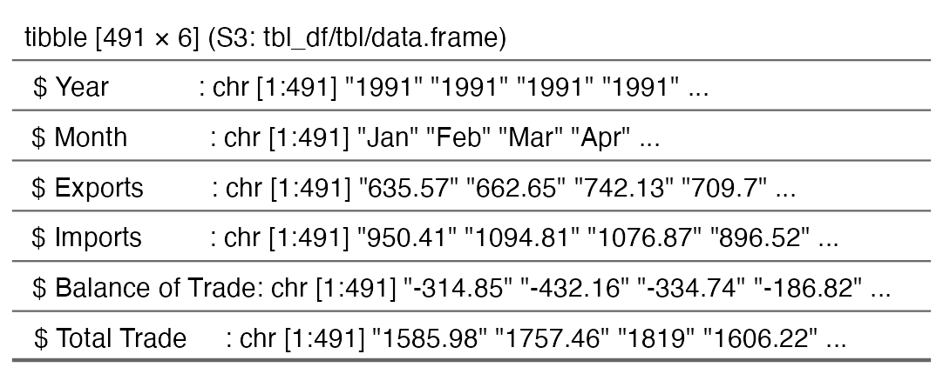

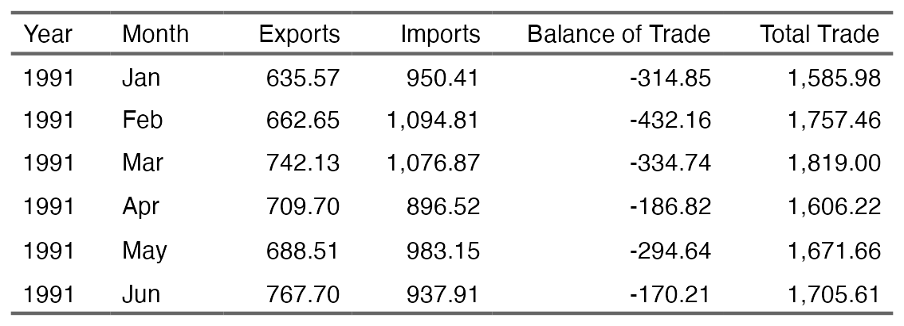

*Figure III.A.1 Object summary of the initial dataset on Philippine Total Trade, Imports, Exports, and Balance of Trade in Goods by Month and Year (1991–2025P) as processed in R. Values are in million USD.*

Following normalization, a summary of annual values was derived to provide a clearer view of trends over time. *Figure III.A.2* illustrates the annual values of the key trade performance indicators used in this study.

Moreover, data for the current year, 2025 has been excluded in the new table to maintain consistency, and avoid potential forecasting bias.   
 *(Please refer to the next page.)*

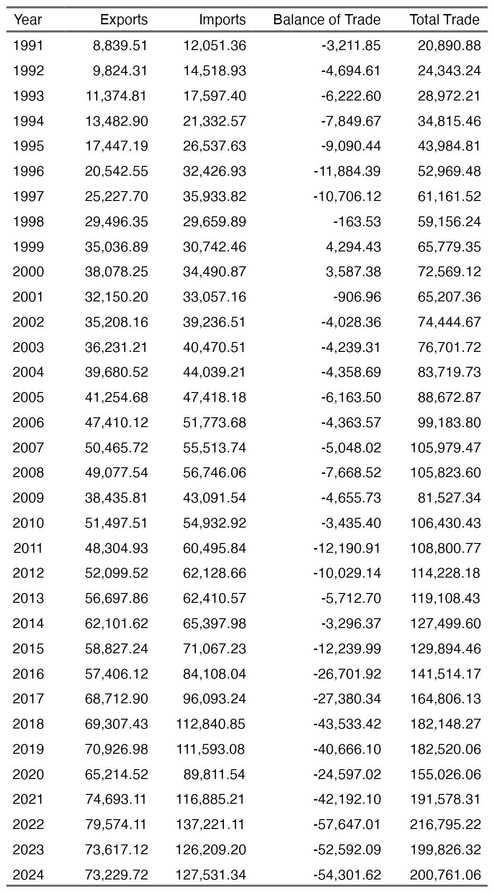

*Figure III.A.2. Philippine Trade: Total, Imports, Exports & Balance (1991–2024*

With the dataset normalized, and key variables extracted, the next step is to perform EDA to extract insights, and set the foundation for the predictive model.

* 1. *Results of Exploratory Data Analysis (EDA)*

The figure below provides key statistics for the Exports, Imports, Balance of Trade, and Total Trade over a 34-year period, measured in million USD. These numbers help us understand general trade patterns, variations, and trends.

Exports

1. The average (mean) exports per year were $45,337.5M, meaning that in a typical year, the Philippines exported around this amount.
2. The highest recorded export value was $79,574.11M, while the lowest was $8,839.51M, showing a large difference in export performance over the years.
3. The standard deviation of $20,656.85M means that exports fluctuated significantly from year to year.
4. The skewness (-0.16) tells us that the export values are fairly balanced, with no extreme years pulling the average too much in one direction.

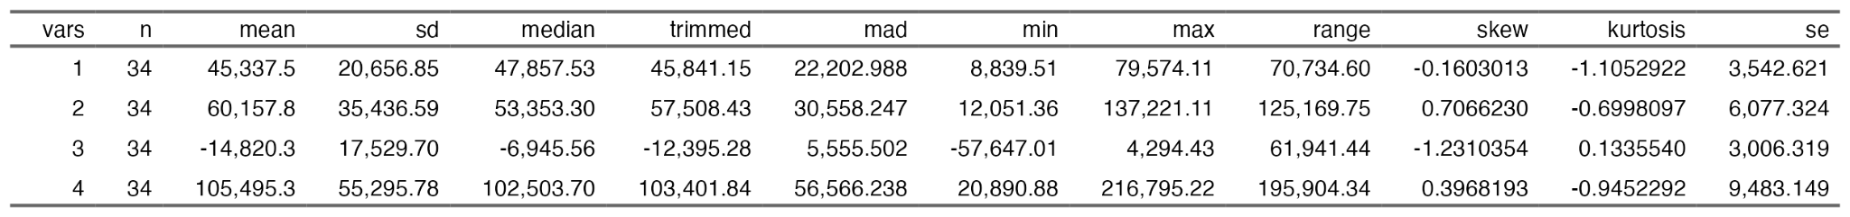

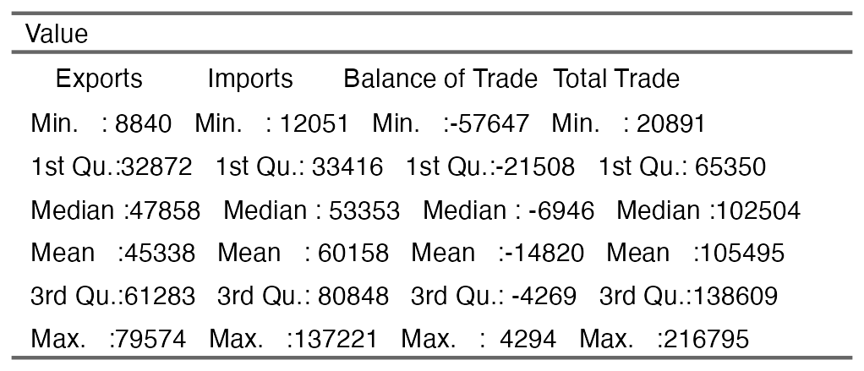

*Figure III.B.1. Descriptive and Summary Statistics of Philippine Trade Data 1991-2024*

Imports

1. The average annual imports were $60,157.8M, higher than exports, indicating a trade deficit.
2. The highest import value was $137,221.11M, while the lowest was $12,051.36M, showing even greater variation than exports.
3. The standard deviation of $35,436.59M suggests imports had larger ups and downs compared to exports.
4. The skewness (0.71) means that there were some years with exceptionally high imports, pulling the distribution slightly to the right.

Balance of Trade (BoT):

1. The average BoT was $-14,820.3M, confirming that the country had a trade deficit (imports exceeding exports) in most years.
2. The highest BoT value (smallest deficit or rare surplus) was $4,294.43M, while the largest deficit was $-57,647.01M.
3. A standard deviation of $17,529.70M means that the trade deficit varied significantly over the years.
4. The skewness (-1.23) indicates that larger deficits were more common than smaller ones, meaning the country frequently experienced significant trade imbalances.

Total Trade (Exports + Imports)

1. On average, the total value of trade (exports + imports) was $105,495.3M annually.
2. The highest total trade value was $216,795.22M, while the lowest was $20,890.88M, again highlighting how trade activity varied widely.
3. The standard deviation of $55,295.78M suggests that the country’s total trade fluctuated significantly.
4. The skewness (0.40) shows that in some years, trade volumes were much higher than usual, but the distribution is not heavily skewed.

In summary, our data indicate that in the past 3.4 decades:

1. The Philippines spends more on imports than it earns from exports. On average, the annual trade deficit is $14.82 billion each year, meaning we import more goods than we sell abroad.
2. Trade values change a lot year-on-year. Exports and Imports both show big fluctuations over time. This is evident in the high values of standard deviations. (Exports: $20.66 billion, Imports: $35.44 billion). This implies that trade performance is not stable and can swing significantly.
3. Imports are the driving factor for the trade gap. The Philippines buys more from other countries ($60.16 billion on average) than it sells ($45.34 billion), which is why the trade deficit exists.
4. There were years with very high trade deficits. The negative skewness of the Balance of Trade (-1.23) means that the country had more years with large trade deficits than years with a balanced or surplus trade.
5. Trade is growing over time. The highest recorded total trade (exports + imports) reached $216.8 billion, showing that the overall volume of trade has increased.
6. Many factors influence trade performance. The ups and downs in trade can be due to changes in global demand, government policies, economic conditions, or currency exchange rates.
   1. *Philippine Trade in Pictures: Trends and Insights*

The numbers on the dataset have expressed their story on the Philippines’ performance in trade. To supplement the insights collected from the data, this section presents charts and graphs that illustrate the key insights extracted from the data.

*(Please refer to the next page.)*

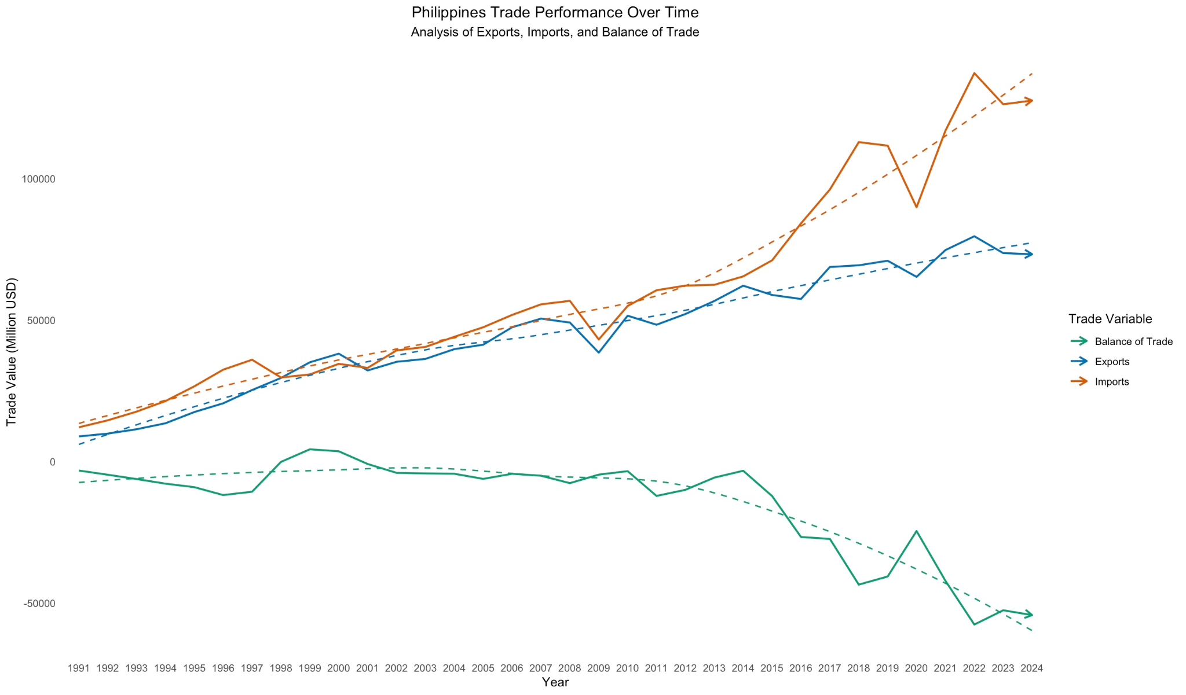

*Figure III.C.1. Philippine Trade Performance Over Time 1991-2024*

Figure III.C.1. Philippine Trade Performance Over Time 1991-2024

Figure III.C.1 shows how the Philippines’ trade has changed from 1991 to 2024, illustrating the values of Exports, Imports, and Balance of Trade values in million USD. The solid lines represent the actual values, while the dashed lines represent long-term trends. Arrows point to the general movement of trade activity (upward or downward).

Key Observations:

1. Consistent Trade Deficit – Imports (orange line) have consistently exceeded Exports (blue line), resulting in a negative Balance of Trade (green line). The country spends more money on imports than it earns from exports, creating a long-term "trade loss."
2. Increasing Trade Volume – Both Imports and Exports show consistent increase for the past 3.4 decades, but the import growth rate appears steeper, widening the trade deficit. The Philippines’ buying (imports) and selling (exports) have increased over time, but the country’s spending on foreign goods is growing faster than its earnings from selling to other countries.
3. Significant Decline of Balance of Trade in 2017 – The Balance of Trade has deteriorated sharply. The trade gap (difference between imports and exports) became more noticeable in recent years, meaning the country relies even more on foreign products for the past eight years.
4. Short-Term Recoveries – Some periods, such as 1998, 2008, and 2020 show brief successes in the trade gap. This could be a result of multiple factors such as global events, policies, etc. Exports improved slightly, but overall, the country continues to import more than it exports.

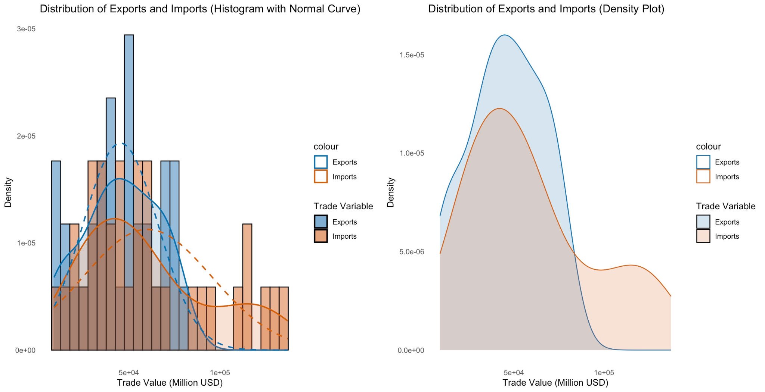

*Figure III.C.2. Variability in Exports and Imports*

Figure III.C.2. Variability in Exports and Imports

Figure III.C.2 shows the changing flow of exports and imports over time using the Histogram & Normal Curve (left), and the Density Plot

Key Observations:

1. Trade Activity is Unpredictable – The histogram shows that both exports (blue) and imports (orange) cover a wide range of values, while the density plot has broad curves. This means the country’s trade numbers go up and down a lot instead of staying steady.
2. More Small Trades, Fewer Big Ones – In the histogram, most trade values are grouped on the lower end, with a few bars stretching toward higher amounts. The density plot also shows peaks at smaller values, gradually dropping off. This means the country usually trades smaller amounts, but once in a while, there are big spikes.
3. Imports Change More Than Exports – The histogram shows import bars are more spread out, and in the density plot, the orange (Imports) curve is wider than the blue (Exports) curve. This means the amount the country spends on imports changes a lot, while export earnings are a bit more stable.
4. Most Trade Happens at Mid-Range Values – The histogram has the most bars in the middle, and the density plot shows peaks at mid-level trade values. This tells us that while the Philippines is active in trade, extremely high trade numbers are rare. Most of the time, trade happens within a typical range.

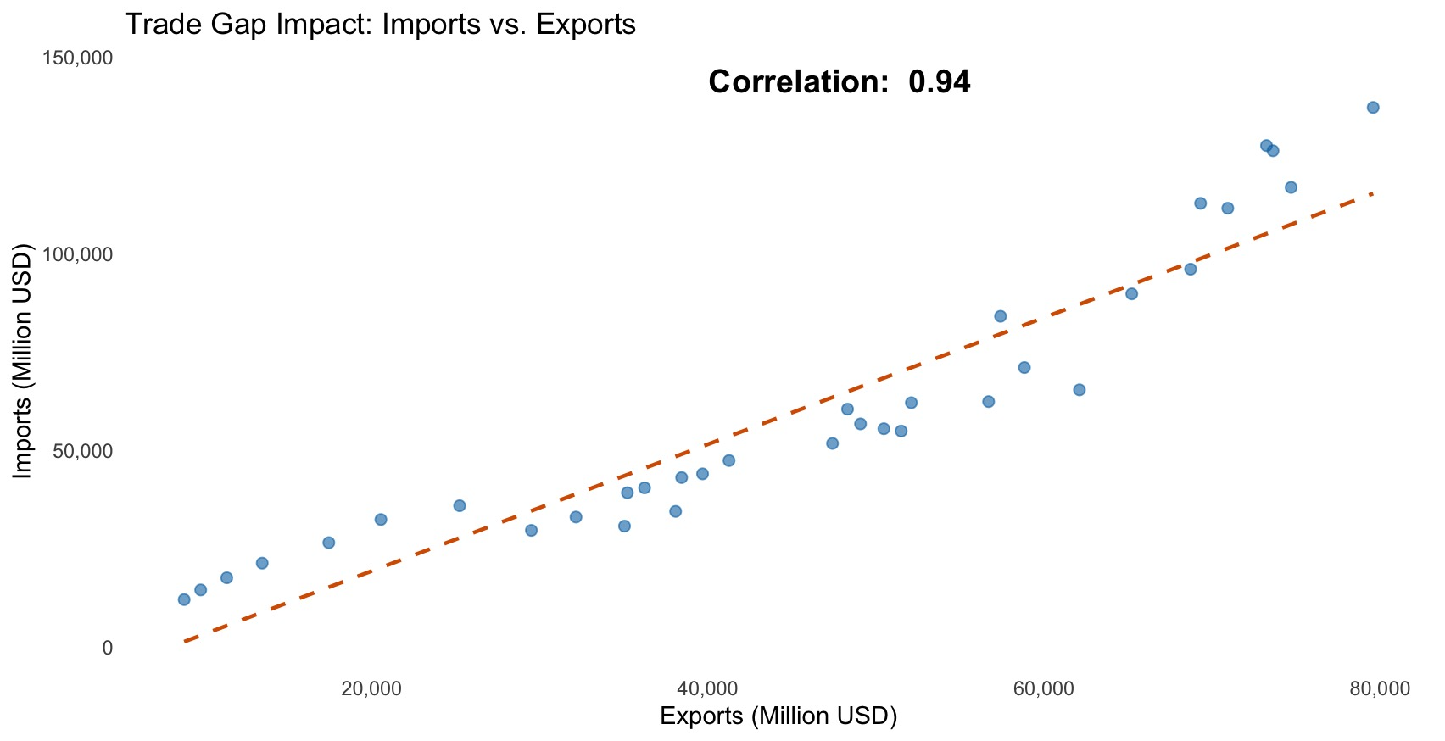

*Figure III.C.3. Trade Gap Impact: Imports vs. Exports*

Figure III.C.3. Trade Gap Impact: Imports vs. Exports

Figure III.C.3 illustrates the relationship between exports and imports using a scatter plot. Each point represents a specific year’s trade activity, showing how imports correspond to export values. The trendline (dashed) indicates the overall pattern, highlighting whether imports consistently exceed exports. The correlation value provides insight into the strength of the relationship between the two variables, helping assess whether higher exports generally lead to higher imports.

Key Observations:

1. Strong Link Between Imports and Exports – The scatter plot shows that when exports (values earned from selling goods to other countries) go up, imports (values spent on buying goods from other countries) also increase. The dashed line shows this strong connection.
2. Imports Are Usually Higher Than Exports – Most points are above the diagonal line, meaning the country often spends more on imports than it earns from exports. This leads to a trade deficit.
3. Strong Relationship Between Imports and Exports – The correlation number on the chart is close to 1, showing that imports and exports grow or shrink together in a predictable way.
4. Trade Gaps Change Over Time – Some years show a much bigger gap between imports and exports than others, meaning the country sometimes relies more on foreign goods, making the trade deficit worse.

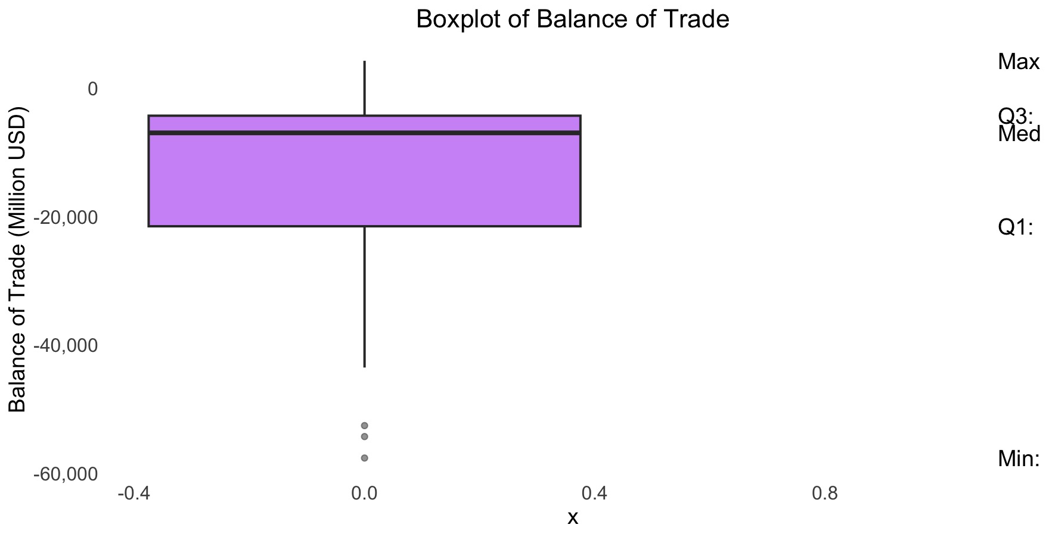

*Figure III.C.4. Balance of Trade (BoT) Distribution 1991-2024*

Figure III.C.4. Balance of Trade (BoT) Distribution

Figure III.C.4 shows the Balance of Trade (BoT) over the years. The boxplot helps us understand if the country has been importing more than exporting, creating a trade deficit.

Key Observations:

1. Trade Deficits Are Common – The boxplot shows that the country often has more imports than exports, leading to a trade deficit. The median (middle value) is negative, confirming this pattern.
2. Most Years Have Deficits – The first (Q1) and third quartiles (Q3) are both negative, indicating that many years see trade deficits, though the deficit size can vary.
3. Wide Range of Trade Balances – The minimum and maximum values show a big difference between the worst trade deficit and the best surplus, showing that trade balance can change a lot from year to year.
4. Negative Skewness – The boxplot’s skewness is indeed visible: the box is pulled downward (due to the median being closer to the lower quartile) and the whiskers stretch further down, showing a concentration of years with larger deficits. The presence of outliers (if any) would further emphasize these extreme years with very large deficits.

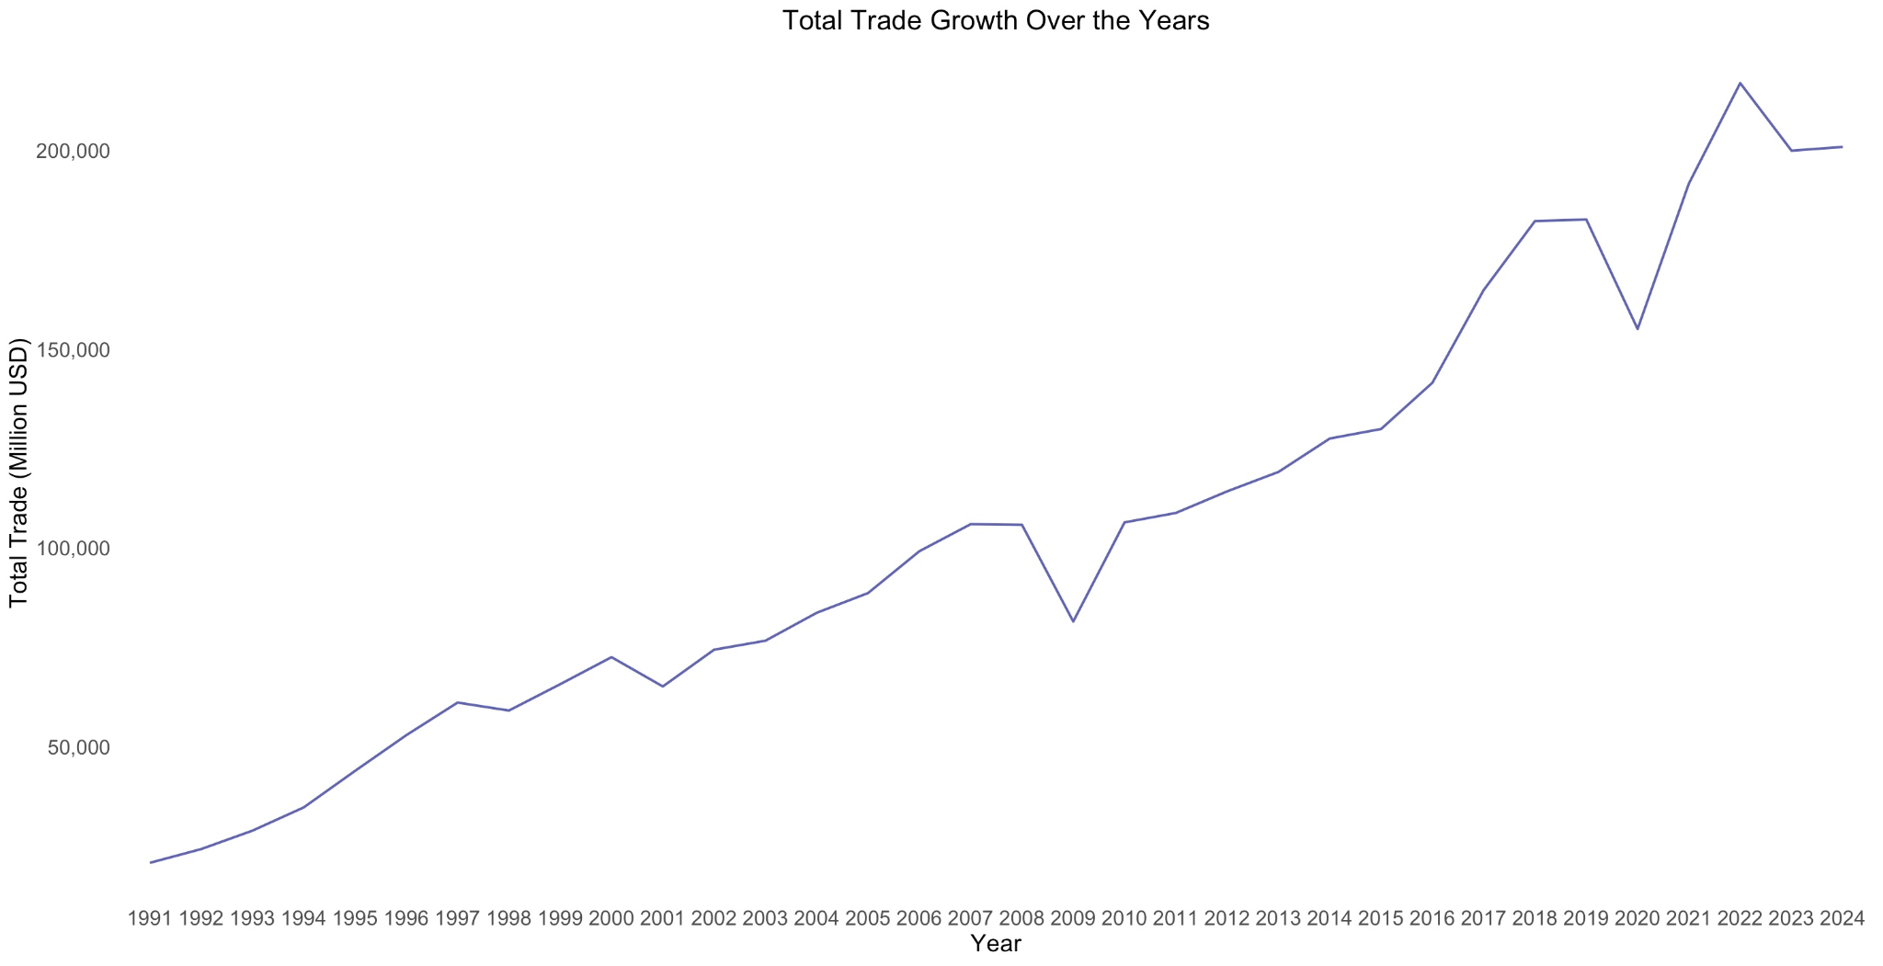

*Figure III.C.5. Total Trade Growth Over the Years 1991-2024*

Figure III.C.5. Total Trade Growth Over the Years 1991-2024

Figure III.C.5 shows an upward trend of Philippines total trade growth (exports plus imports) from 1991 to 2024. Despite the BoT deficits, the Philippines’ trade volume has consistently increased overtime.

Key Observations:

1. Consistent Growth – The chart shows a clear upward trend, indicating continuous expansion in total trade over the years.
2. Quick Recoveries After Dips – While some periods show declines, the trade volume rebounds swiftly, maintaining overall growth pace.

* 1. *Macro-Summary of Philippines’ Trade Trends (1991-2024)*

Taking a look at the bigger picture, the Philippines has performed consistent trade growth over the past three decades with both exports and imports steadily increasing.

However, the unfavorable outcome of trade deficits persist to increase despite the growth in trade volume as imports continuously outperforms exports.

Key Takeaways:

1. Widening Trade Gap – The Balance of Trade (BoT) has been negative for most years, with a sharp decline starting in 2017, highlighting the country’s growing reliance on imports.
2. Strong Import-Export Relationship – Exports and imports move together, but imports grow at a faster rate, widening the trade imbalance.
3. Trade Volume Expansion – Despite deficits, total trade has shown a steady upward trend, with occasional short-term declines that are quickly recovered.
4. Negative BoT Distribution – The boxplot confirms the dominance of trade deficits, with a negatively skewed distribution indicating frequent years of significant trade losses.

To summarize in one sentence – the country's trade activity and performance is growing, yet the rising trade deficit implies the country’s dependency on imported goods posing challenges for economic sustainability and long-term improvement.

# Creating the Predictive Model Through Linear Regression of The Philippines’ Trade Performance

To create a predictive model of the Philippines’ trade performance based on the available trade data from 1991 to 2024, both simple regression and multiple linear regression will be applied and implemented through RStudio.

Relationships between individual variables will be explored using simple linear regression. To analyze the combined effect of multiple variables, multiple regression will be used.

1. *Model Formulation – Linear Regression*
2. Variable Selection

In the context of our dataset, this research will be using the following variables:

*Independent (Predictor) Variables:* These are the factors this research hypothesizes might influence the Balance of Trade (BoT), which are (1) Exports, and (2) Imports.

*Dependent (Response) Variable:* This is the variable that this research will try to predict. This is Balance of Trade (BoT), the difference between exports and imports. It is significant since the Balance of Trade (BoT) is a key indicator for trade performance.

1. Linear Regression Formulas

The formula for simple linear regression is:

*Y = β0​ + β1​ X + ϵ*

Where:

*Y* is the response variable, the value of Balance of Trade in million (USD) that this research will predict.

*β0​* is an intercept, value of *Y* when *X = 0*

*β1* is the slope (coefficient), which tells the change in *Y* for a one unit change in *X​X* is the predictor variable used to predict *Y,* which in this research will be the values of Exports, and Imports

*ϵ* is the margin of error, otherwise known as the residual value.

Therefore:

*BoT = β0​+β1​⋅Exports + ϵ*

for Exports as predictor; and

*BoT = β0​+β2​ ⋅ Imports + ϵ*

for Imports as a predictor. *β2* is the slope coefficient of imports.

For multiple linear regression, the formula will be:

*BoT= β0​+β1​ ⋅ Exports + β2​ ⋅ Imports + ϵ*

Where:

BoT is the Balance of Trade (response variable).

*β0* is the intercept (value of BoT when Imports = 0).

*β2* is the coefficient (slope) for Imports, representing how much BoT changes with each unit change in Imports.

*Imports* is the predictor variable.

*ϵ* is the residual or error term.

1. Implementation in RStudio

3.1 Validating Suitability

To determine whether there are significant relationships between the variables in the dataset, a validation process must first be conducted.

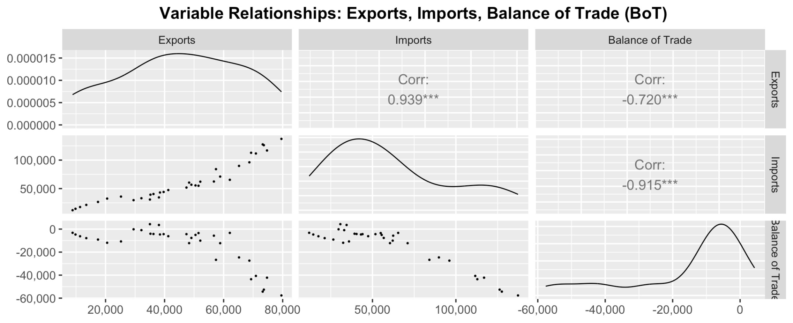*Figure IV.A.1. Relationships of Exports, Imports, and Balance of Trade*

### Relationships of Exports, Imports, and Balance of Trade

The scatter plot matrix provides a visual representation of the relationships among exports, imports, and the balance of trade (BoT). Each scatter plot shows how two variables interact, while the diagonal density plots display the distribution of individual variables.

Exports vs. Imports

The scatter plot of exports and imports (bottom-left) shows a strong upward trend, meaning that as exports increase, imports also tend to rise. The high correlation value (0.939) confirms that the Philippines’ trade activity is highly interdependent—higher exports are accompanied by increased imports.

Imports vs. Balance of Trade

The scatter plot between imports and balance of trade (bottom-center) reveals a clear downward trend.This aligns with the strong negative correlation (-0.915), indicating that as imports grow, the trade deficit worsens. The density plot at the bottom suggests that BoT values are mostly negative, reinforcing the notion that the country operates under a trade deficit.

Exports vs. Balance of Trade

The scatter plot of exports and BoT (bottom-right) also shows a negative correlation (-0.720). This suggests that higher exports reduce the trade deficit, but the effect is weaker compared to imports’ impact on BoT. The density plot of BoT (bottom row, last column) shows a distribution skewed toward negative values, reflecting the persistent trade deficit.

These behaviors and insights from the summarized visualization align with the earlier discussions in this research. The findings reinforce the strong relationships among the variables, confirming their suitability for the predictive model.

3.2 Building the Linear Regression Model Equations

Using programmed commands/functions in R, separate simple linear regression models will be created to predict the future values of our response variable, Balance of Trade.

The figures below present the summary statistics for the three models. Models 1 and 2 employ simple linear regression, while Model 3 utilizes multiple linear regression with Exports and Imports as predictor variables..

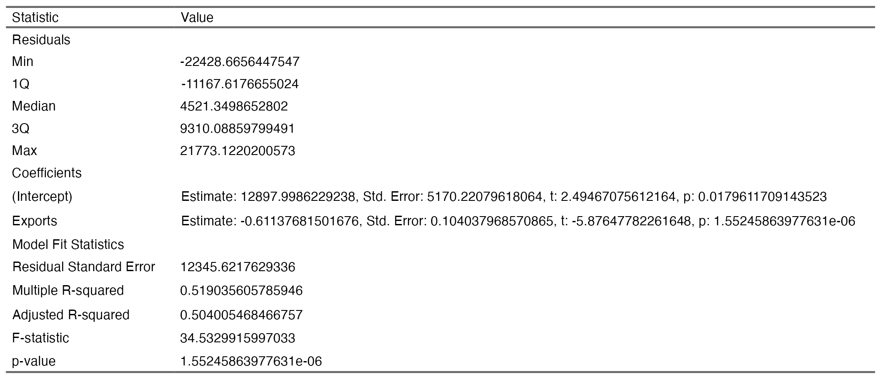

*Figure IV.A.2. Linear Model 1–Balance of Trade ~ Exports*

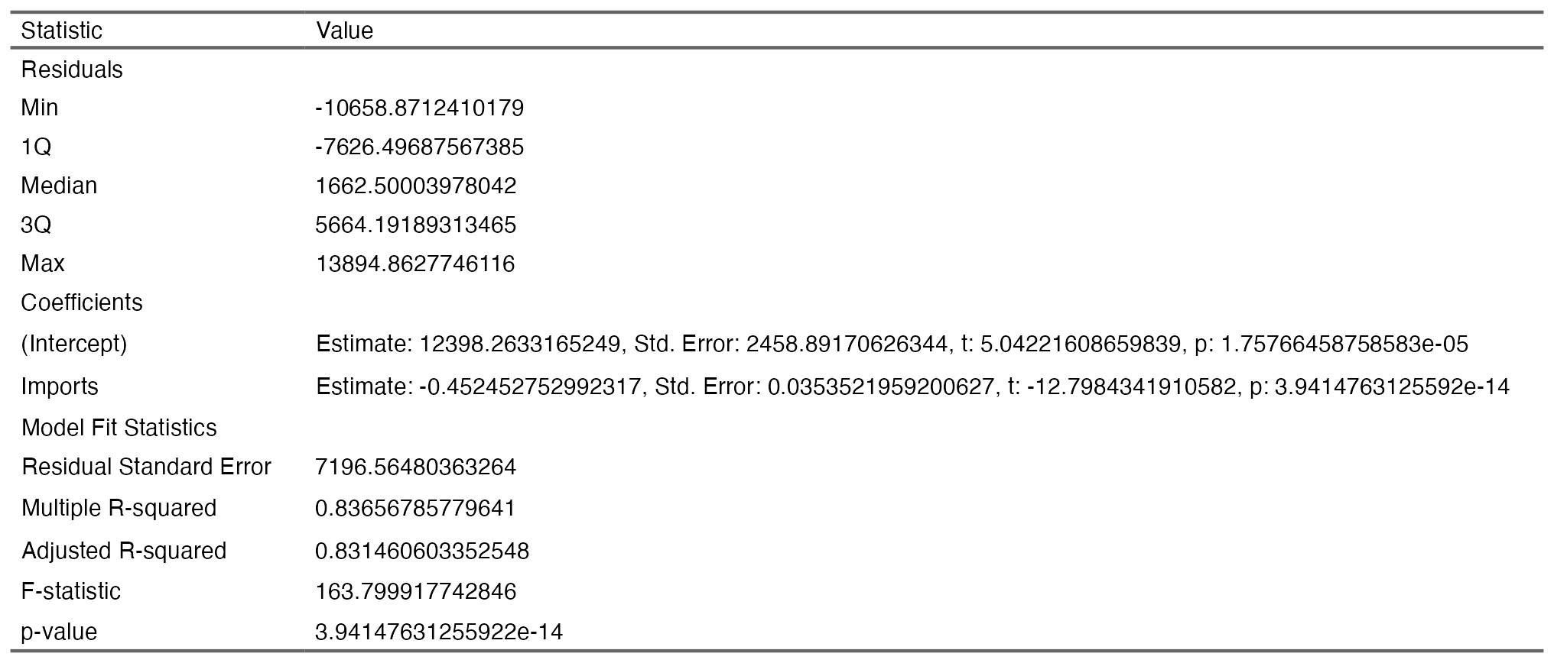*Figure IV.A.3. Linear Model 2–Balance of Trade ~ Imports*

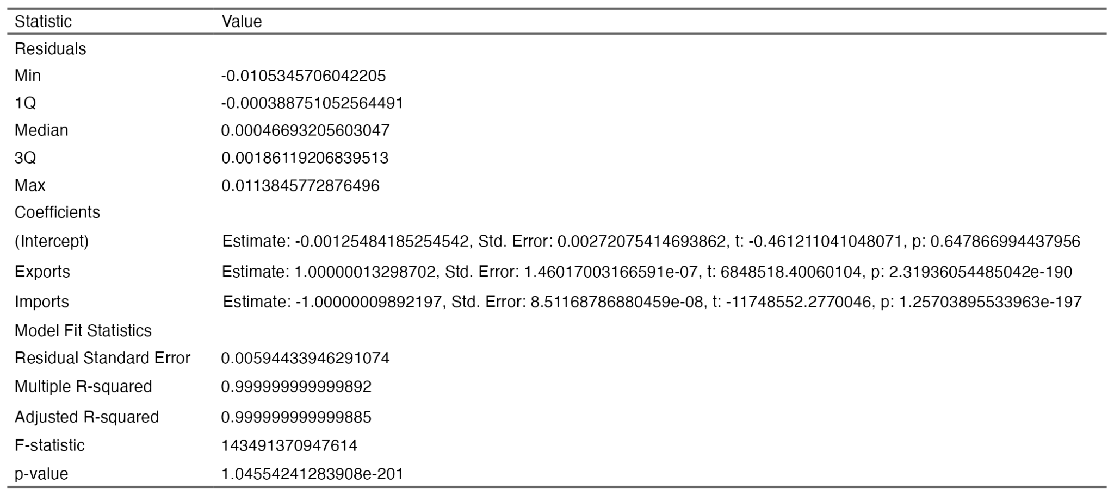*Figure IV.A.4. Linear Model 3–Balance of Trade ~ Exports + Imports*

Based on the summary statistics of our prediction models, the resulting equations are as follows:

*BoT = 12897.9986 ​+(-0.6114 * Exports)+ ϵ*

*BoT = 12398.2633 + (-0.4525 * Imports) + ϵ  
BoT=-0.0013 + (1 * Exports)+(−1.0000×Imports)+ϵ*

With the regression equations established, the next step is to evaluate the models to determine which one best fits the data. This selection will be based on key statistical measures which are:

1. Residual Standard Error (RSE): Measures how much our predictions typically differ from actual Balance of Trade values. Lower is better.
2. Multiple R-Squared: Shows how well the model explains Balance of Trade variations. Closer to 1 is ideal.
3. Adjusted R-Squared: Similar to R-Squared but adjusts for the number of predictors, preventing misleading results.
4. F-Statistic: Tests if at least one predictor significantly impacts Balance of Trade. Higher suggests a better model.
5. p-value: Indicates if predictors meaningfully contribute. A value below 0.05 suggests significance, meaning the results are unlikely due to random chance.
6. *Model Selection*

Using the statistical measures that were identified in the previous sections, a comparison of the three research models will be performed to pick the most suitable predictive model for Philippine Trade Performance.

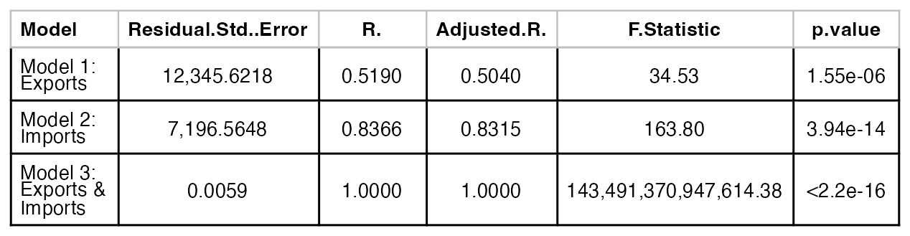*Figure IV.B.1. Summary of Significant Statistical Measures for Philippine Trade Performance*

Figure IV.B.1 presents the summary statistics of the three predictive models used to analyze the Balance of Trade. By comparing their statistical performance, we can determine which model provides the most reliable and accurate predictions.

Residual Standard Error

Model 3 shows near-perfect predictions, but this is misleading. Since Balance of Trade is calculated as Exports minus Imports, this model is simply reproducing the same values rather than making actual predictions. Model 2 has a lower Residual Standard Error (RSE) than Model 1, meaning its predictions are closer to the actual Balance of Trade values.Model 1 has the highest RSE, indicating larger deviations between predicted and actual values, making it the least accurate model among the three.

R-squared and Adjusted R-squared

Model 3 reports an R² of 1.000, but this occurs because the model is simply reconstructing the Balance of Trade formula rather than identifying meaningful relationships. Instead of offering new insights, it mathematically restates that Balance of Trade is equal to Exports minus Imports, leading to an artificially perfect fit. This makes Model 3 invalid for predictive purposes, as it does not reveal any deeper patterns in the data. Model 2 has an R² of 0.8366, meaning it explains 83.66% of the variation in Balance of Trade, making it the strongest explanatory model. Model 1 has a lower R² of 0.519, indicating that it explains only 51.90% of the variation, missing key factors influencing Balance of Trade.

F-Statistic and p-Value

All three models are statistically significant, as indicated by their extremely low p-values (p < 0.05) Model 3’s F-statistic is unrealistically large. Model 2 has a higher F-statistic than Model 1, meaning it is the more statistically robust model.

Identifying the Best Predictive Model

Model 3 is not a valid choice, as it merely reflects the Balance of Trade formula rather than making meaningful predictions.

Model 2 (using Imports to predict Balance of Trade) is the best model, as it has the highest explanatory power (R² = 0.8366), the lowest prediction error (RSE = 7,196.56), and strong statistical significance. Model 1 (using Exports to predict Balance of Trade) is weaker than Model 2, as it explains less variation in the data and has a higher error margin.

Based on these statistical evaluations, Model 2, denoted by the equation

*BoT = 12398.2633 + (-0.4525 * Imports) + ϵ*

is the most reliable and accurate model for understanding the trends in the Philippine Balance of Trade. It provides strong predictive power while maintaining statistical validity, making it the best choice for further analysis. This means that:

*“The Philippine Trade Balance starts at 12,398.26 million USD, but for every 1 million USD increase in imports, the trade balance decreases by 0.4525 million USD, assuming other factors remain constant.”*

1. *Model Evaluation*

To ensure our model accurately predicts the Philippine trade balance, we analyze its residuals—the differences between actual and predicted values. If these residuals are randomly scattered around zero, the model is making fair predictions.

However, if they show a pattern, it means the model is biased, consistently overestimating or underestimating trade balance. Checking the residual distribution helps confirm whether our model provides a reliable representation of how imports impact the country’s trade balance.

In addition, the model scatter plot will be used to help visualize how well our fitted model predicts the Philippine trade balance based on imports. Ideally, the data points should closely follow the regression line, indicating that the model accurately captures the relationship.

If points are widely scattered or show a curved pattern, it suggests the model doesn’t fully explain trade balance fluctuations, possibly due to missing factors. Take note, that the dataset in this research is on the macro-level.

A well-fitted model means the predictions align closely with actual trade balance values, ensuring more reliable insights for understanding the impact of imports on the country’s trade deficit or surplus.

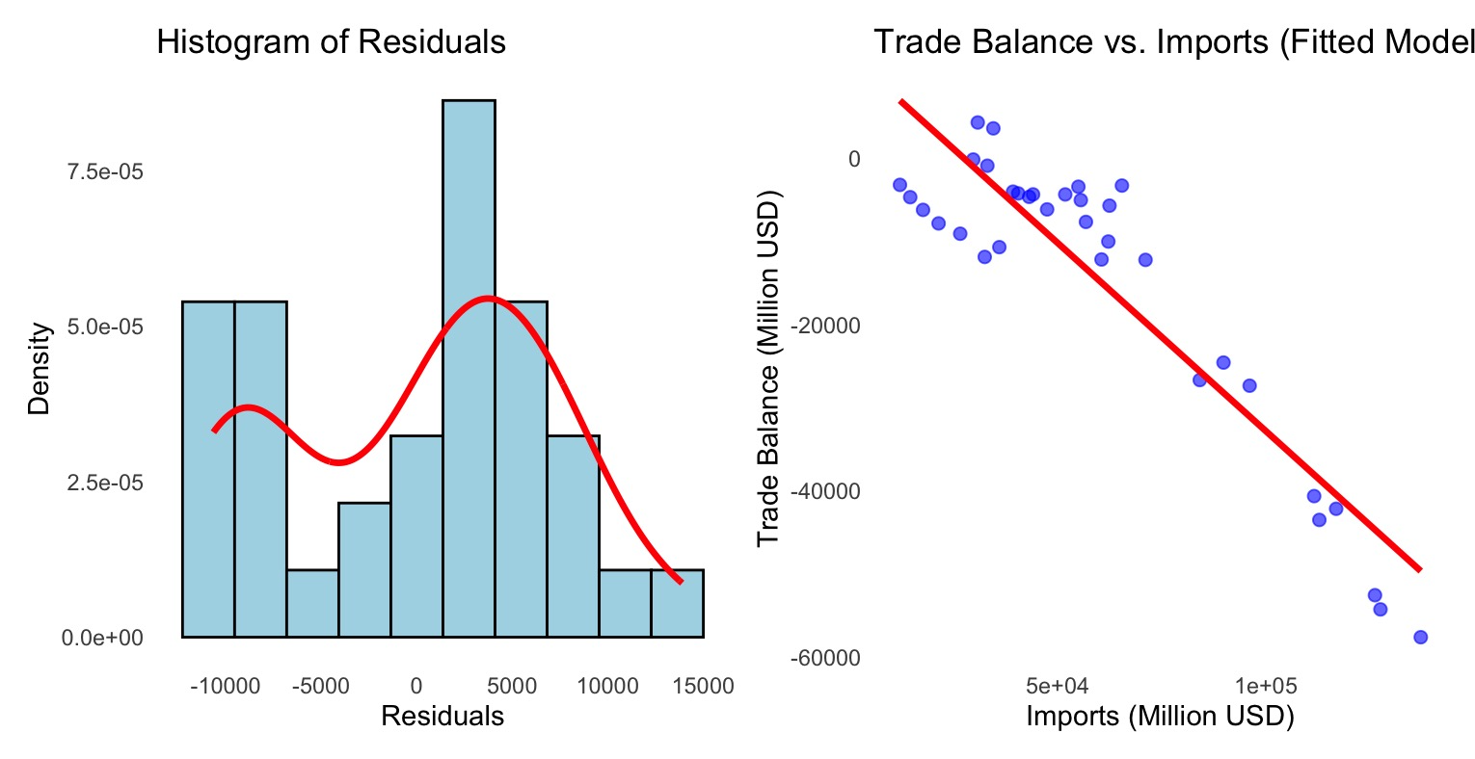

*Figure IV.C.1. Residual Distribution and Model Scatter Plot*

In the figure above, the histogram of residuals suggests that the model does not yet fully capture the relationship between the predictor and the response variable. This can be seen by the following indicators – normal distribution curve (ideally shaped like a perfect curved bell) and spread of residuals, which show deviations such as skewness or irregular patterns when it is supposed to be symmetrical around zero. This can be attributed to factors indicated in the limitation of this research.

The regression analysis reveals a strong negative relationship between imports and the trade balance, confirming that as imports rise, the Philippines experiences greater trade deficits. While the model provides useful insights, refining it with additional variables or a more complex approach could improve accuracy and better inform trade policy decisions.

1. *Model Testing – Making Predictions*

Now that the predictive model has been initially assessed, the next step is to apply it for further analysis. First, the model will be used to predict the Balance of Trade (BoT) using the actual trade data.

These predicted values will then be compared with the actual BoT from the dataset to assess the model's accuracy.

Finally, a detailed evaluation will be conducted, including visualizations, to better understand the model's performance and identify areas for improvement.

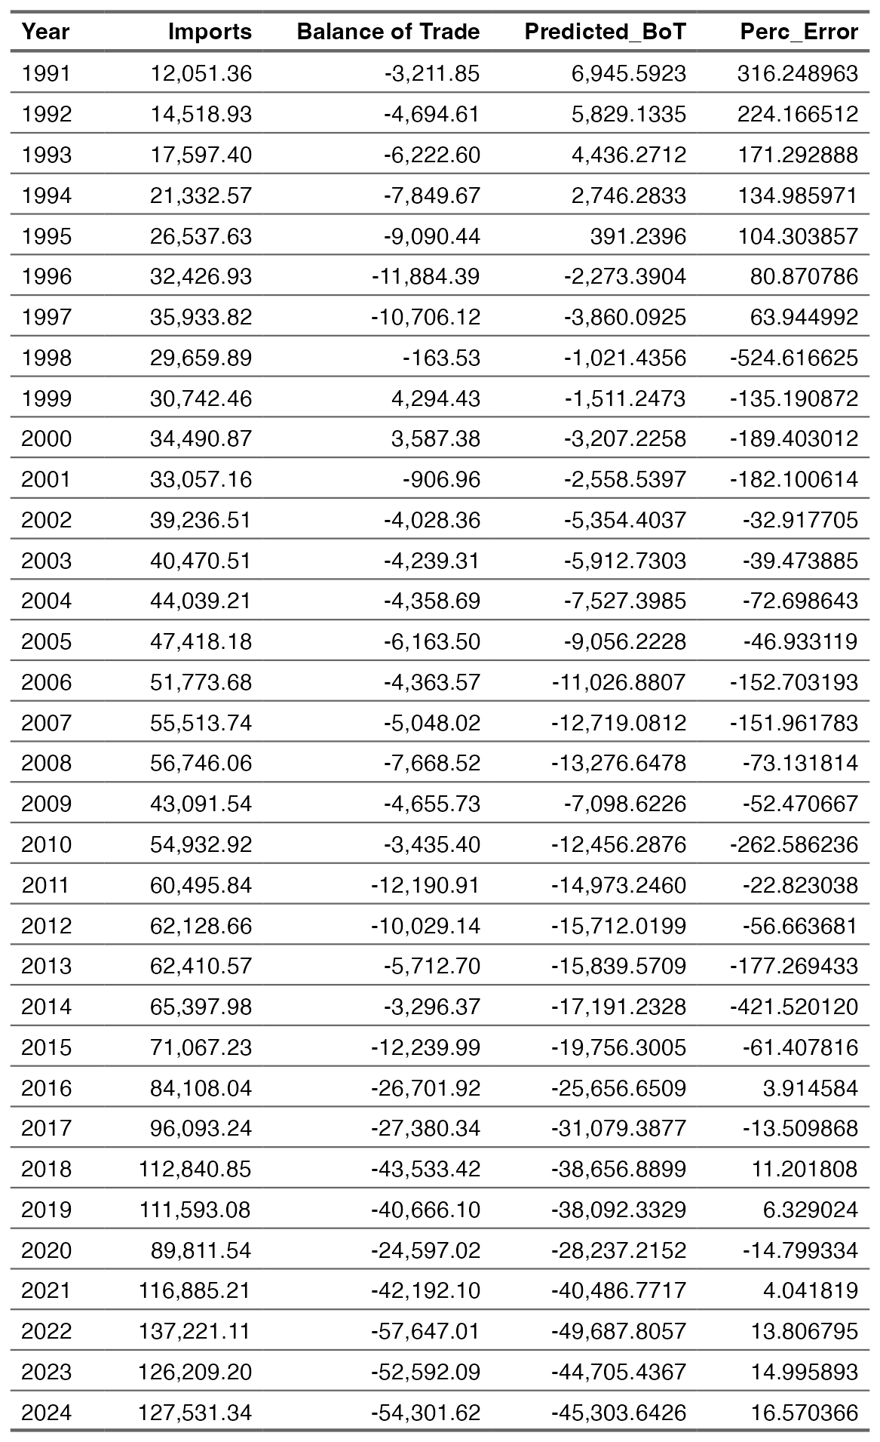

*Figure IV.D.1. Actual Balance of Trade vs Predicted Balance of Trade with Percent of Error*

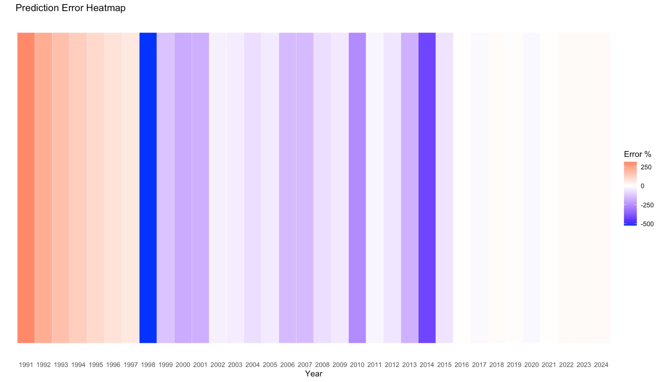

*Figure IV.D.2. Prediction Error Heatmap*

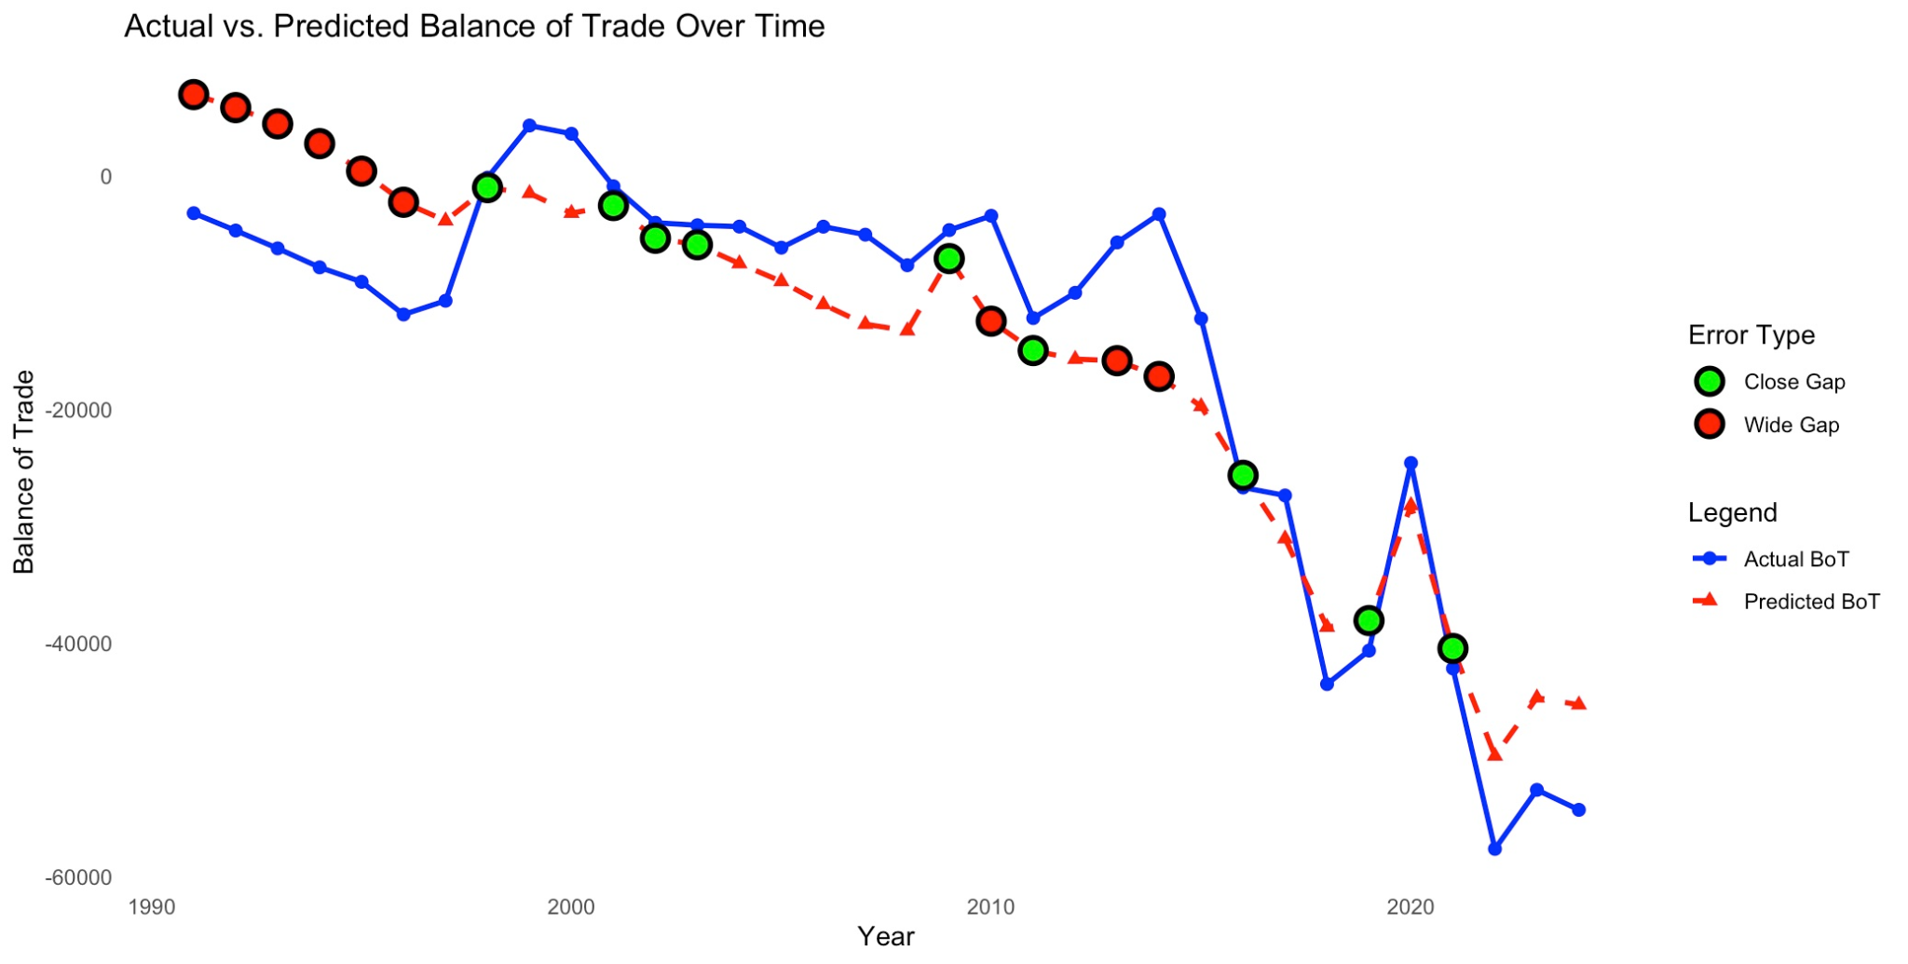

*Figure IV.D.3. Actual Balance of Trade vs Predicted Balance of Trade with Percent of Error*

Figures IV.D.1 to IV.D.3 illustrate the differences in the Balance of Trade (BoT) when modeled as a response variable of Imports, compared to the historical, actual Balance of Trade values. These visual representations highlight the model’s predictive accuracy and areas of deviation, offering insights into how well imports alone can explain trade balance fluctuations over time.

The heatmap visualizes the prediction error percentage, indicating the magnitude and direction of errors across different years. Red shades indicate positive errors (overestimation of BoT). Blue shades indicate negative errors (underestimation of BoT). White or light colors indicate small errors (good predictions).

Key Observations in the Heatmap

1. In the 1990s, many red shades suggest that the model consistently overestimated the trade balance when the actual Import values were fed into the linear model equation.
2. The deep blue segment around 1998 indicates a large underestimation.
3. In more recent years (post-2015), the errors appear to be smaller, suggesting better model accuracy.

The line chart shows actual vs. predicted Balance of Trade over time, highlighting areas with close and wide prediction gaps. The blue line represents the actual Balance of Trade (BoT), while the red dashed line represents the predicted values.

Key Observations in the Line Chart:

1. In some years, the predicted BoT closely follows the actual values, but in others, there are significant deviations. These are indicated by the green and red dots. Green dots signify a close gap, which means the model’s predictions were closely correct to the actual values. Red dots signify the opposite, indicating large errors in the predictions.
2. Similar to the patterns in the heatmap, deviations between historical and actual BoT values are more concentrated in the earlier years and gradually decrease over time.

These insights into the prediction errors and model accuracy can be used to assess the overall fitness of our model, and supplement the findings of the assessment conducted during model formulation and selection helping us better understand the model's strengths and limitations and determine how well imports alone can explain fluctuations in the Balance of Trade.

1. *Assessment, Verdict, & Strengths and Limitations of the Model*

To evaluate the reliability and effectiveness of our model, we combine the results obtained during our model selection, and the insights obtained from the prediction phase.

1. Model 2, which uses Imports as the predictors for the values of Balance of Trade (BoT) emerged as the best choice, demonstrating a strong statistical fit, lower error rates, and well-distributed residuals, ensuring both accuracy and interpretability.
2. The heatmap of prediction errors and the line chart comparing actual versus predicted values highlight both the strengths and weaknesses of our model. In the earlier years, the model struggled to make accurate predictions, often overestimating or underestimating the trade balance. However, as time progressed, the predictions became more aligned with actual values. This improvement suggests that the model can be useful for forecasting future trade balance trends, especially with further refinements.

Strengths:

1. Captures the Trend & Relationship – The predictive model successfully reflects the overall movement of the trade balance, making it a useful tool for tracking trade performance based on import data.
2. Improved Accuracy Over Time – Despite the large errors in earlier periods, the selected model’s accuracy improved as time went by, where errors became smaller, particularly in recent years.

Limitations:

1. Huge Errors with Older Data – The model struggles with accuracy when applied to older data, as seen in the values in the 90’s period.
2. Limited Scope of Data – The model is solely using annual total value of imports, and does not yet take into account various factors that happen in the real world such as:
   1. global events (COVID-19 Pandemic, Global Recession, etc);
   2. seasonality of demand;
   3. sectors and industries;
   4. domestic and international political landscape (change in administration, legislations, etc); and many more.
3. Direct Straight Line Relationship – The model assumes a straight, direct linear pattern, which does not fully reflect the actual dynamics of trade in the real-world.

In summary, Model 2 is still the best option among the three options. However, its accuracy is weaker in earlier periods, and it does not fully capture all factors affecting trade.

To improve future forecasts, additional economic variables and more advanced modeling techniques could be explored.

# Comparison of Research Insights vs Existing Literature

1. *Key Findings*

In this research, the relationship between variables and their impact to the Philippines’ Balance of Trade has been clearly identified. In addition, a predictive model that can be used to forecast future annual values of the Philippines’ Balance of Trade. There are two key finding from this research which are:

1. Growing Trade Activity – This is signified by the increasing annual values of both Exports and Imports.
2. Growing Trade Deficits – The Balance of Trade, one of the key indicators of a country's economic performance, has been on the decline, leaning towards negative values. This suggests that the country’s reliance on imported products is heavy.

These findings suggest that while increasing trade activity might mean a dynamic economic movement for the Philippines, the persistent trade deficit raises concerns about long-term sustainability.

If ignored, the pros of the Philippines’ dynamic economic movement may be outweighed by the detrimental effects of growing trade deficits.

To dive further on these insights, comparing the findings of this research with existing literature may help us obtain more context.

1. *Review of Related Literature*

International trade participation is a key driver of economic growth, according to Salcedo, et al[4]. However, in the case of the Philippines, this research is still uncertain whether the country’s trade relationships have significantly improved the lives of Filipinos.

In a research published by Clarete[5], the Philippines’ participation in international trade did bring positive effects to the Philippine economy. These are indicated by an increase in the country’s Gross Domestic Product (GDP), increase in employment opportunities, and an increase in foreign investments. However, it also brought drawbacks such as decline of local industries, particularly the agriculture, and the manufacturing sector.

Another study by Biemudo et al. [6] analyzed the impact of trade liberalization on the Philippine economy also reveals findings that a vital sector–agriculture has suffered due to trade liberalization as the country increasingly relied on importing agricultural products.

In a separate publication by Deluna [7], findings also suggest that:

1. In the lives of the regular Filipinos – Trade can improve welfare by enhancing economic performance, creating jobs that can potentially increase income.
2. Trade Benefits –  The Philippines made strong connections with East Asian nations such as China, Japan, South Korea, and ASEAN members, helping increase export potential. The membership in APEC also reduced trade inefficiencies significantly, enhancing export flows.
3. Sectors that Suffered – The country experienced a consistent trade deficit, which aligns with the findings of this research where imports exceed exports.
4. Inflation and Peso Valuation – Due to trade deficits, foreign currencies strengthened against the peso, which makes buying imports more expensive. This has also led to the devaluation of the peso.
5. Philippines as a Global Trade Player – While the country is recognized for its strong links in the APEC countries, the country's performance in the ASEAN, and WTO countries are insignificant. ​Despite having untapped export potential, the country has not fully made the most out of its trade relationship, especially in the ASEAN region.

Based on the findings of cited literature, and the data from this research, the growth in both trade activity and deficits suggests that trade has had a mixed impact on the Philippines, bringing both benefits and challenges. Further research and a more comprehensive review of existing literature could provide deeper insights into the long-term implications of trade on the country's economy.

# Reflection

Conducting this research and analysis has proven to be more than just an exercise for software commands for the researcher. While the purpose of the activity was to help the researcher obtain a comprehensive understanding on the application of statistical and data analysis methods, the researcher also gained a *“slightly deeper”* understanding on trade and economy.

Trade and the economy are more than just terminologies used by economists, traders, and academic scholars—they are concepts that directly impact our daily lives. While it can be studied in a macro-level such as in this research, it can also be studied and implemented in the micro-level. The buying behaviors of Filipinos, for instance, are more than just personal preferences; collectively, they shape the country’s trade patterns, influencing economic stability.

Trade is a two-way relationship—we are affected by policies, import/export trends, and global economic conditions, but at the same time, our choices as consumers, businesses, and policymakers actively shape the trade landscape.One key realization is the significant role of supporting local industries. Prioritizing domestic products not only strengthens the trade balance but also fosters job creation, promotes economic self-sufficiency, and reduces dependence on foreign markets.

On the subject of policymakers, another important realization is the significance of our social responsibilities, particularly in the context of electing government officials. The people we vote into office play a direct role in shaping trade policies, economic strategies, and national priorities—the macro-level forces that influence trade. Their decisions on tariffs, trade agreements, and industry regulations ultimately impact businesses, consumers, and the overall economy. Well-crafted legislation can promote national interests by fostering fair trade, protecting local industries from harmful competition, and ensuring sustainable economic growth. This reinforces the idea that individual choices, from voting to purchasing behavior, collectively shape the country’s economic landscape.

# Conclusion & Recommendations

This research explored the relationships among Exports, Imports, and the Balance of Trade in the Philippines. By applying statistical and data analysis methods, the study identified significant patterns and trends that extend beyond the dataset, offering insights into broader economic frameworks. The findings highlight the country’s increasing trade activity, alongside a growing trade deficit, emphasizing the critical role of imports in shaping the nation’s economic landscape.

While the predictive model provides valuable insights into trade performance, its limitations suggest the need for further refinement and consideration of additional economic variables.

Given the findings this research, a few key actions, as well as areas for further research are recommended:

Consumers - the General Filipino Public

Start making better choices and be aware—small decisions matter. Whether it’s selecting a smartphone or electing a government official, these choices contribute to the country’s economic direction. Supporting local businesses and SMEs not only strengthens domestic industries but also helps create a more sustainable and balanced trade environment. Individual actions, when combined, shape national progress.

Policymakers

Perform comprehensive and regular evaluation of the country’s trade performance. Implement trade policies that support domestic industries while maintaining a balanced import-export relationship. Craft legislation that protects local businesses and encourages sustainable economic growth.

Businesses

Develop strategies to enhance competitiveness in international markets while strengthening local supply chains to reduce dependence on imports.

Future Researchers

Expand the predictive model by incorporating additional economic indicators such as exchange rates, foreign investments, and global trade policies to improve accuracy and reliability. Limitations and opportunities of this research can be further improved and scaled.

The researcher hopes that the findings of this research can be used as a catalyst for positive change, and aid in the alleviation of the country’s economy, and improve the Filipino way of life.

# Acknowledgments

The researcher would like to humbly express his gratitude to the following creatures and entities:

*The Creator* – for the gift of life and talents, even if the researcher is still figuring out how to use them properly, and hopefully for monetary gains.

*Rodolfo C. Raga Jr., PhDCS* – for his insightful feedback, inspiration and challenging the researcher to explore beyond the box.

*August the Pomeranian* – the researcher’s canine co-author for his significant contribution & company.

*Innovators and Technologists* – for developing the tools and platforms that made research, data analysis, and visualization possible.

*Researchers and Academics* – for their dedication to expanding human knowledge. Their studies and insights have provided the foundation and direction for this work.

*Online Resources & Communities* – for making information accessible to all. In particular–*Elicit* for or assisting in gathering relevant research papers, summarizing key insights, and making the literature review process more efficient.

*Peers & Readers* – for your time in perusing this research. Your feedback and suggestions will be invaluable in refining and improving the researcher’s work.

And last but not the least, and at the risk of potentially receiving a failing mark from Mr. Raga, and a trip to the Student Development Office:

*ChatGPT* – for being an ever-patient sounding board, code debugger, and occasional sanity saver throughout this research journey. For a researcher with limited time, resources, experience in research writing, knowledge and expertise in a variety of subjects required (and brain capacity included), artificial intelligence has been a supplemental tool for the researcher to breakdown data from various sources, narrow down ideas, understand and digest an overwhelmingly big amount of information, a non-sentient partner that patiently (thankfully) answered even the researcher’s most nonsensical questions and clarifications.

May this acknowledgment not result in academic repercussions!

# Appendix

List of Installed R Packages

The following table presents the R packages utilized in this research, along with their respective versions:

Package Version

psych 2.4.12

magrittr 2.0.3

knitr 1.49

gridExtra 2.3

dbplyr 2.5.0

broom 1.0.7

zoo 1.8-13

tidyr 1.3.1

lubridate 1.9.4

forcats 1.0.0

stringr 1.5.1

dplyr 1.1.4

purrr 1.0.4

readr 2.1.5

tibble 3.2.1

tidyverse 2.0.0

patchwork 1.3.0

ggplot2 3.5.1

webshot2 0.1.1

flextable 0.9.7

car 3.1-3

carData 3.0-5

*Note: This is a non-exhaustive list. The data were processed in R in multiple sessions.*

# 

# References

1. L. C. Abueg, “An Econometric History of Philippine Trade: 1810–1899,” DLSU Business & Economics Review, vol. 26, no. 2, pp. 125–146, 2017.
2. Philippine Statistics Authority, “Foreign Trade Summary,” OpenSTAT, [Online]. Available: https://openstat.psa.gov.ph/PXWeb/pxweb/en/DB/DB__2L__IMT__SUM/0012L4DFTS0.px/?rxid=bdf9d8da-96f1-4100-ae09-18cb3eaeb313. [Accessed: 18-Mar-2025].
3. Jack Hetherington, “Cat co-authored influential physics paper,” Science, [Online]. Available: https://www.science.org/content/article/cat-co-authored-influential-physics-paper#:~:text=CC%20BY%202.0)-,In%201975%2C%20Jack%20Hetherington%20and%20F.D.C.,a%20cat%2C%20Atlas%20Obscura%20writes. [Accessed: 13-Mar-2025].
4. J. C. C. Salcedo, F. G. Vigonte, and M. V. Abante, "Philippine International Trade Participation: Key to Boost Economic Growth," SSRN, [Online]. Available: https://ssrn.com/abstract=4454229. [Accessed: 18-Mar-2025].
5. R. L. Clarete, "An Analysis of Philippine Trade Policy," MPRA Paper, No. 51677, 2013. [Online]. Available: https://mpra.ub.uni-muenchen.de/51677/. [Accessed: 18-Mar-2025].
6. K. G. Biemudo, R. V. Antonio, and N. A. J. Agustin, "An Empirical Analysis on the Impact of International Trade in Philippine Economic Growth," *J. Econ. Finance Account. Stud.*, vol. 4, no. 1, pp. 607–628, 2022. [Online]. Available:<https://www.al-kindipublisher.com/index.php/jefas>. [Accessed: 18-Mar-2025].
7. R. S. Deluna Jr., "Trade Performance and Potential of the Philippines: An Application of Stochastic Frontier Gravity Model," Munich Personal RePEc Archive, Paper No. 51677, Apr. 30, 2013. Available: https://mpra.ub.uni-muenchen.de/51677/. [Accessed: 18-Mar-2025].

To God be the Glory!